

**CSE2004**

**DATABASE MANAGEMENT SYSTEM**

**Community Book House Centre**

**Report Submitted To:**

Faculty Name: Dr. S.L. Jayalakshmi

School: SCOPE

**Report Submitted By:**

Member 1: Adavelli Rohan Reddy 20BRS1270

Member 2: Neeraj J Manurkar 20BRS1269

Member 3: Devanshu Khemka 20BAI1319

**INDEX**

|  |  |  |
| --- | --- | --- |
| **SI**  **No.** | **CONTENT** | **PAGE No.** |
| 1. | ACKNOWLEDGMENT | 3 |
| 2**.** | ABSTRACT | 4 |
| 3. | (i)INTRODUCTION  (ii)Why DBMS is needed for this project?  (iii)Existing system  (iv)Proposed methodology | 5-9 |
| 4. | ER DIAGRAM AND RELATIONAL SCHEMA | 10-11 |
| 5 | ARCHITECTURE DIAGRAM | 12 |
| 6. | MODULES | 13-15 |
| 7. | TECHNOLOGIES AND  INTEGRATION | 16-19 |
| 8. | IMPLEMENTATION DETAILS (SOFTWARE USED) | 20 |
| 8. | DATABASE DESIGN | 21-23 |
| 9. | CODE |  |
| 10. | DATABASE |  |
| 11. | WEBSITE |  |
| 12. | CONCLUSION AND FUTURE  ENHANCEMENTS | 24 |
| 13. | REFERENCES | 25 |

**ACKNOWLEDGMENT**

"It is not possible to prepare a project report without the assistance and encouragement of other people. This one is certainly no exception.

On the very outset of this report, we would like to extend our sincere & heartfelt obligation towards all the personages who have helped us in this endeavor. Without their active guidance, help, cooperation & encourgement, we would not have made headway in the project. We are ineffably indebted to our faculty Dr. S.L. Jayalakshmi for her conscientious guidance and encouragement to accomplish this assignment in its presently.

We extend our gratitude to VIT Chennai for giving us this opportunity. We also acknowledge with a deep sense of reverence, our gratitude towards our parents and members of our family, who have always supported us morally as well as economically.

At last but not least gratitude goes to all of our friends who directly or indirectly helped us to complete this project report. Any emission in this brief acknowledgement does not mean lack of gratitude.

**ABSTRACT**

* A Community Book house Centre is a project that manages and stores books information electronically according to community memvers(users) needs. The system helps both users and the book house manager to keep a constant track of all the books available in the respective center. It allows both the admin and the user to search for the desired book.
* This project has many features which are generally not available in normal Book House center like facility of user login, login as guest to donate the books. It has a facility of admin login through which the admin can monitor the whole system. It has a facility where user after logging in their accounts can see list of books issued and its issue date and return date. Alse we have different login portals for the community members and admin.

# INTRODUCTION

* In present day, most of the people don’t have a habit of reading books. Even if there are people who are interested, they don’t want to spend money to buy a book but rather rent.
* So, we came up with the idea of a ‘Community Book House Center’ where a book house can be set up in large communities and they can borrow books to read in a hassle-free way.
* We believe this will help people to reconnect with books and enjoy reading.
* Since our platform will be 100% digital, there will be no physical waste, data errors or time delay which are often faced in the manual book management. Our project will also eliminate the issue of whether the desired book is there in the book house and if not present then it can be recommended in the feedback section.
* This project is developed in php, MySQL, CSS, HTML,Bootstrap which mainly focuses on basic operations in a library like adding new books, and updating new information, searching books and users and return books.
* For creating front-end we used CSS, Bootstrap and HTML. MySQL has been used for back-end and php is used to interact with backend

# OBJECTIVES

Objectives of Community Book house Centre are-

* To build a system where we can enter the record of new books and retrieve the details of books available in the library.
* To build a system which can issue the books to the community members (users) and maintain their records.
* To store properly the Book House items in order to maintain their security.
* To enter and preserve details of the various issues and keep a track on their returns.
* To manages the accounts of users which includes their name, id, borrowed items and etc.
* To manages the fine if return date of book is exceeded.
* To give people the chance to donate the books which they do not need by login in as guest.

**WHY DBMS FOR THIS PROJECT**

* No need of manual record which take up large space when there are many users, like in a community.
* The data can be more efficient and detailed
* Possibility of human error is less and there is no possibility of duplication of data.
* There will be more storage capacity.

# EXISTING SYSTEM

* There are not many community book house centers currently in India.
* Even in the existing ones all the transactions are done manually. Even if the database is maintained digitally the fines are calculated manually and also since there is no easily available record of the books present, the user would waste good amount of time in searching for the desired book.
* Some of the existing systems doesn’t have proper details stored in the database such as the total number of users, interests of the users and etc.

# LIMITATIONS OF EXISTING SYSTEM

Some of the limitations of existing system are-

* Not proper retrieval of information.
* Not all the entries are made in offline system.
* Possibility of human made error is highly expected.
* More space consuming for hard copies of data.
* Manual calculation of fines
* User records are not stored which can help in knowing their interested genre.

**PROPOSED SYSTEM**

* Proposed system is an automated Community Book house Centre.
* Every transaction, payment, details are present in the digital format, so there are little to no chances of errors.
* Through our website user can add books, search books, renewal, update information, edit information, and return books in quick time.
* Also, since the admin will have all the user history they can notice which genre is mostly liked and add more books from that category.

# ADVANTAGES OF PROPOSED SYSTEM

Some of the advantages of Proposed system are-

* User friendly interface.
* Fast access to database.
* User can give feedback of his/her experience.
* More storage capacity.
* Quick transaction.
* Books list can be modified based on the user’s preferences.
* No human error.

**ER DIAGRAM**

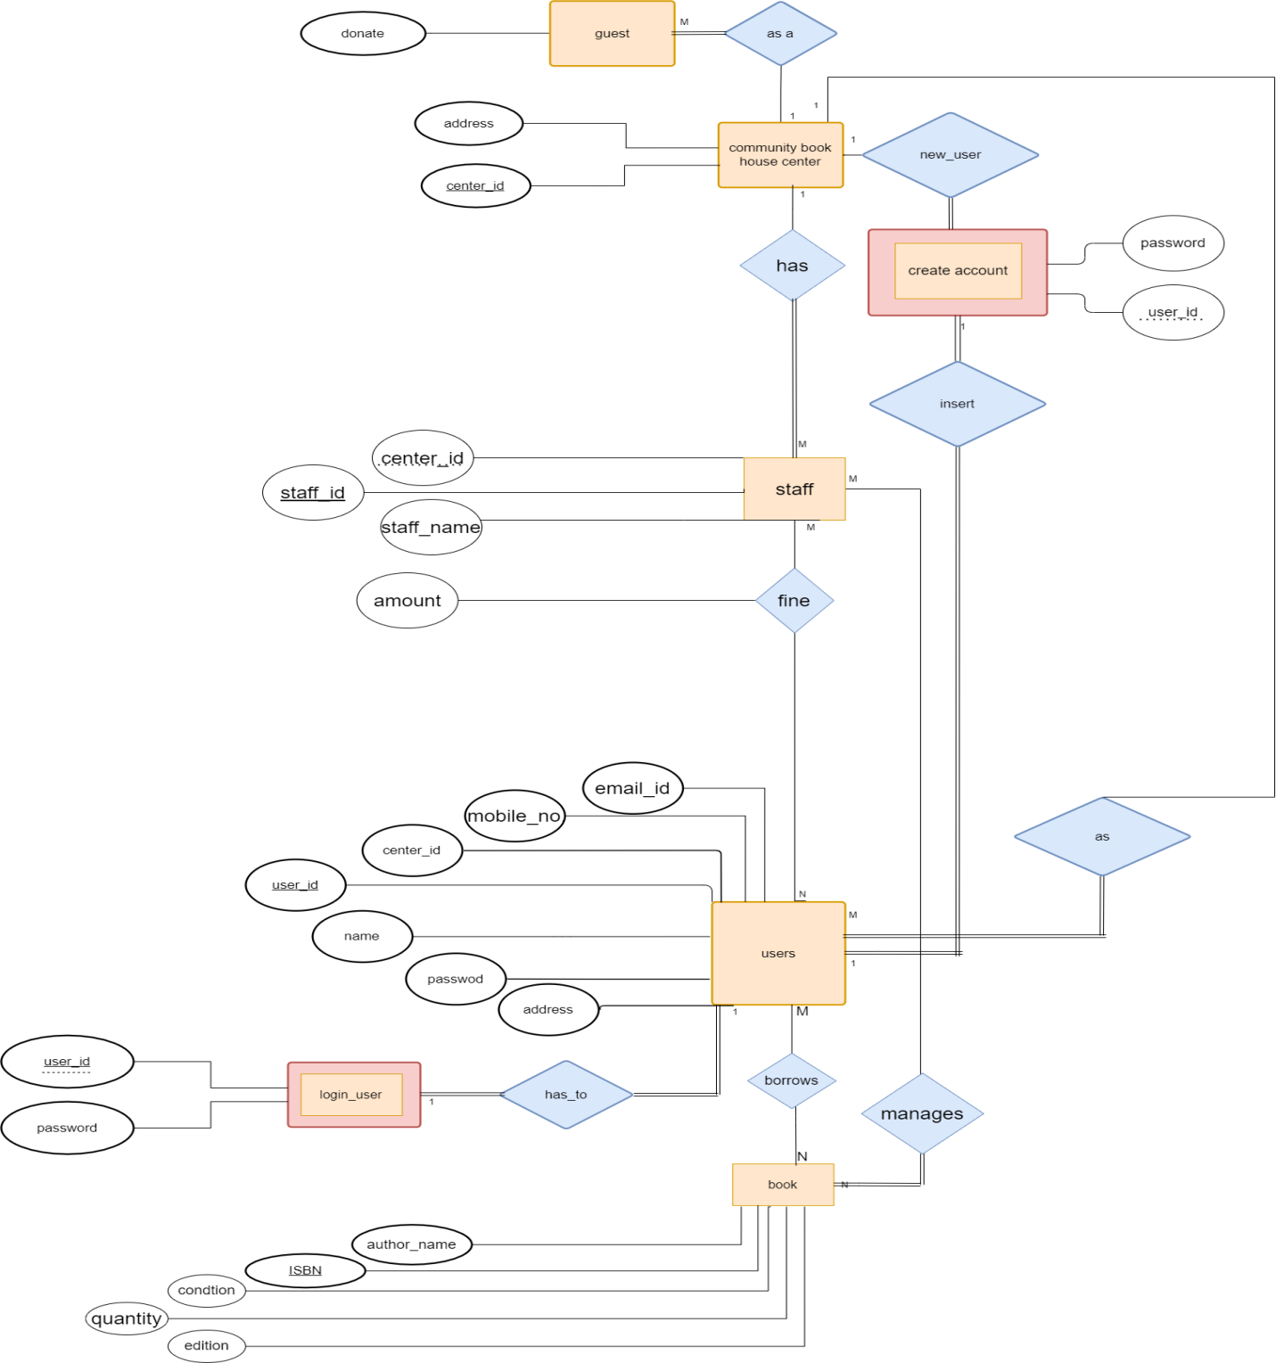

**RELATIONAL SCHEMA**

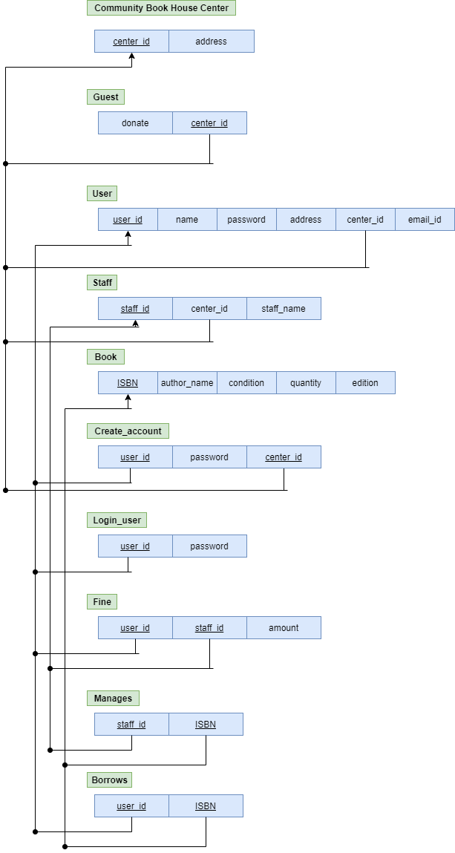

**ARCHITECTURE DIAGRAM**

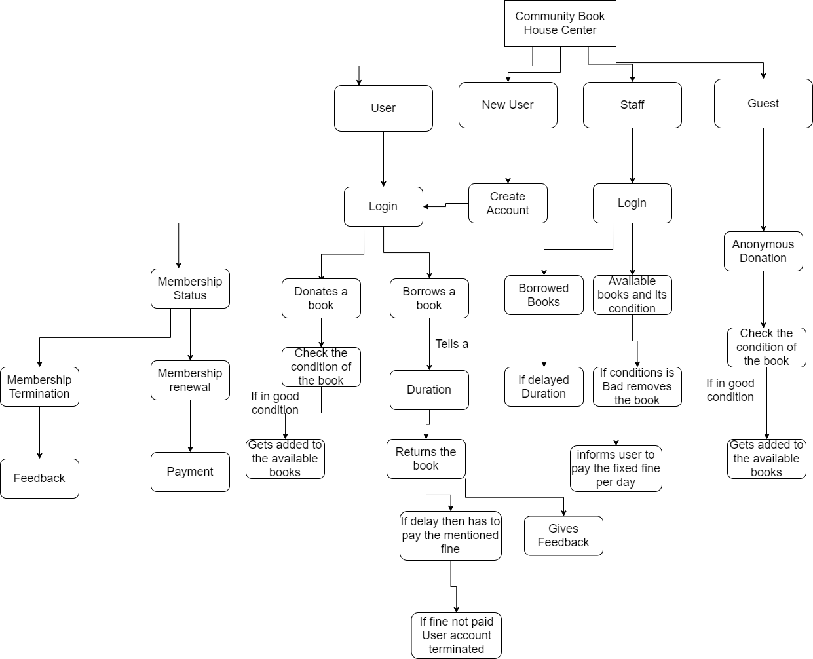

• When the users enter the COMMUNITY BOOKHOUSE CENTER, they have to either sign up or login in to the community room website to avail the facilities of reading room.

• After they login the entries of their activities (like which book is read, time when user logged in and logged out) is stored in Book house database.

• The library staff has to assign the book only after that user will be able to borrow the book. This information also would be stored in the

BOOKHOUSE CENTER database.

• So, the internal Level or schema is the part of the system architecture which is not visible to end users but the actual information of database is stored in it.

• External level or schema is the part visible to the users on their screen where they will have to first login and then enter their activities.

• Conceptual level is the connection between the internal and external levels.

**MODULES**

## Module 1 – Registration

In this module, we are registering all the community members (users) in the system, they can register themselves through the sign-up option. Only the users who are registered can login and request for books.

Firstly, the users need to register themselves by going on the sign-up option and by filling all the required details they can easily register themselves and can request for the books they require.

If later the user feels to edit the profile, they can easily edit their information and also reset their password by going to profile > edit > submit.

Basically, we have two different registering portals, one is for the users and guest and the other one is for the admin department. From the admin login one can see the activities of all the users.

## Module 2 – Login and Logout

The default user of our Community Book house center is admin. Admin can see the community members information, add books, delete books, issue books and can also see the feedback given by other users.

A person can also login as guest if he/she just want to donate the book(s).

## Module 3 – Books

In this module we are displaying information from the database regarding all the books that are available in the community book house center.

The community members can search books by the book name as well as from book the department. After finding out the book they can request for the particular book by book id, which is unique. Then they can see the issue status in the “Issue Information” section.

Now, the admin can see and issue the book from the admin side by going to the “Book Request” page.

Now, if the respective member has returned the book, then admin can update the information by going to “Expire List” and by giving the community member’s username, book id and then pressing the submit button.

Admin can add and delete the book by admin side and the following data will be updated in the database of the community book house center at the back-end.

## Module 4 – Fines

In this module we will display the fines of the community members who have not returned the book on time. The fine will be calculated till the time the book issued is returned back.

This section contains information such as the username, book id, date of return, days, fine in Dollars, status.

## Module 5 – Feedback form

In this module, we are taking the feedback from the users whether did they liked the book, its quality, the edition we can provide them. Also if the condition of the book was appropriate or not. If they were fine with the service we provided them or do they want some changes to be made.

In the feedback form a user can feel free to write down their respective comments so that the admin department can work accordingly.

**Module 6 - Guest**

A person can donate a book even without registering to our community book house center

This option is available in user index page

He/she can utilize feedback option to ask any query and this can also be done without registration

**TECHNOLOGIES AND INTEGRATION**

The tools and programming languages used in this project are as follows

1.PHP

PHP is an acronym for "PHP: Hypertext Preprocessor". It is a widely-used, open source scripting language. It scripts are executed on the server. It is free to download and use.it is powerful enough to be at the core of the biggest blogging system on the web (wordpress). It is deep enough to run large social networks. It is also easy enough to be a beginner’s first server side language.

2.HTML

HTML stands for Hyper Text Markup Language. It is the standard markup language for creating Web pages. It describes the structure of a Web page. It consists of a series of elements. It elements tell the browser how to display the content. It elements label pieces of content such as "this is a heading", "this is a paragraph", "this is a link", etc.

.

3. Bootstrap

Bootstrap is **a framework to help you design websites faster and easier**. It includes HTML and CSS based design templates for typography, forms, buttons, tables, navigation, modals, image carousels, etc. It also gives you support for JavaScript plugins. Basically it is **a free and open source front end development framework for the creation of websites and web apps**. ... In computers, the word bootstrap means to boot: to load a program into a computer using a much smaller initial program to load in the desired program (which is usually an operating system)

1. CSS

[**CSS**](https://developer.mozilla.org/en-US/docs/Glossary/CSS) (Cascading Style Sheets) allows you to create great-looking web pages,. CSS is a cornerstone technology of the [World Wide Web](https://en.wikipedia.org/wiki/World_Wide_Web), alongside HTML and [JavaScript](https://en.wikipedia.org/wiki/JavaScript). CSS is designed to enable the separation of presentation and content, including [layout](https://en.wikipedia.org/wiki/Page_layout), [colours](https://en.wikipedia.org/wiki/Color), and [fonts](https://en.wikipedia.org/wiki/Typeface). This separation can improve content [accessibility](https://en.wikipedia.org/wiki/Accessibility), provide more flexibility and control in the specification of presentation characteristics, enable multiple [web pages](https://en.wikipedia.org/wiki/Web_page)to share formatting by specifying the relevant CSS in a separate .css file and reduce complexity and repetition in the structuralcontent.

1. MySQL

It is a relational database management system based on **SQL-** Structured Query Language. The application is used for a wide range of purposes, including data warehousing, e-commerce, and logging applications.

The most common use for mySQL however, is for the purpose of a web database. It can be used to store anything from a single record of information to an entire inventory of available products for an online store.

In association with a scripting language such as **PHP** or **Perl** (both offered on our hosting accounts) it is possible to create websites which will interact in real-time with a mySQL database to rapidly display categorised and searchable information to a website.

**IMPLEMENTATION DETAILS (SOFTWARE USED)**

* We have used the software phpMyAdmin for the implementation of the website COMMUNITY BOOK HOUSE CENTER.
* All ‘behind the scene’ working of the connection of database and webpage was taken care of by XAMPP by just migrating the files.
* We have used bootstrap to make the website look attractive.
* We have used HTML language for describing the structure of web pages.
* CSS has been used for the layout, font, colour( to make it attractive) of the webpage.
* The admin can access and control the details of each user, the books they have borrowed, the books they have returned, pending dues, due date, feedback they have given etc.
* We have used Visual Studio Code for text editing ans sublime text editor for code editing.
* These data are strictly inclusive for the admin and no other external person or user can access it

**DATABASE DESIGN**



We need data flow diagram to give us an accurate representation of our website will work

Once the user login into the community Book House center, he will have four options that is user, new user, staff and guest. So, the person that has logged in into the community book house center as new user has to create an account and once, he/she creates account he will be added to the users.

So, once he had logged in as a user, he will have three options that is to borrow a book, to modify profile and to check the membership status.

So now if you decide to borrow a book you will be allowed to borrow a book and you have to tell a certain amount of time for when you will be borrowing the book, that is duration. Once the duration is over and you will return the book, the staff will check whether there is delay in returning the book or at the correct time. User can fill a feedback form to clarify any queries. If there is delay in returning the book you will have to pay fine that is mentioned which we have fixed per dat and if the user doesn't pay the fine his account will be terminated.

You can modify the details if any error is found by clicking in edit in the user profile page.

After that the last option is to check the membership status. If you want to check your membership status there are two ways either you can renew your membership or terminate the same. So, if you want to renew the membership you can go to the payment portal and if you don’t want to renew membership and terminate it, we will terminate your membership and we will you can fill the feedback form of our Book House center so that we can know the reason.

Moving on to guest, if you don't want to login and just want to donate a book you can do so as a guest. Once you donate the it will be added to our book list.

The last way to login is there for staff. Our staff also have separate login portal for the community book house center and once the login they will have two options, either they can check the borrowed books or can check the available books. Once they click on the available books, they allowed to see how many books are available and their condition, the second which is the most important one would be boring books, they check the status of each user, like how many books they have borrowed and the get to know whether the duration is delayed or not so once they identify whether the user has delayed for returning the book.

# CODE

**USER**

**PROFILE.PHP**

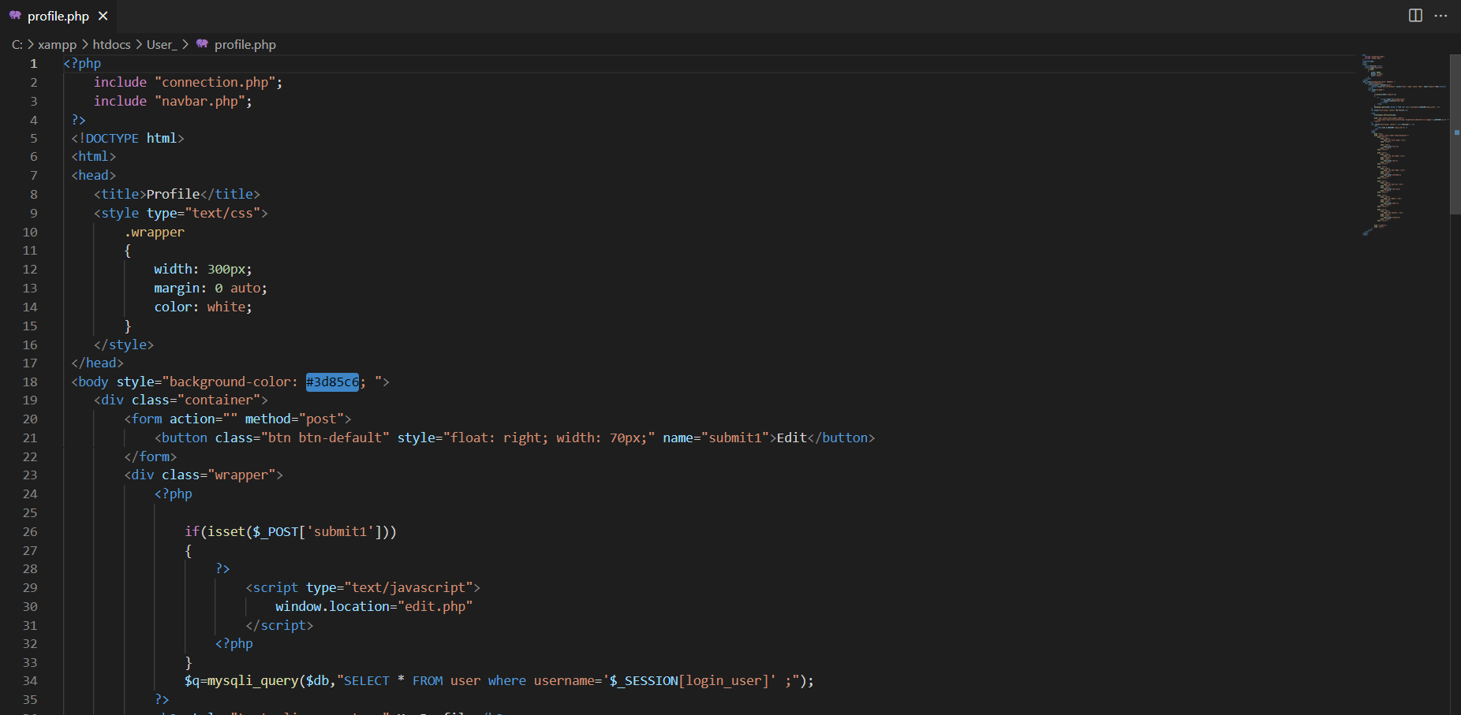

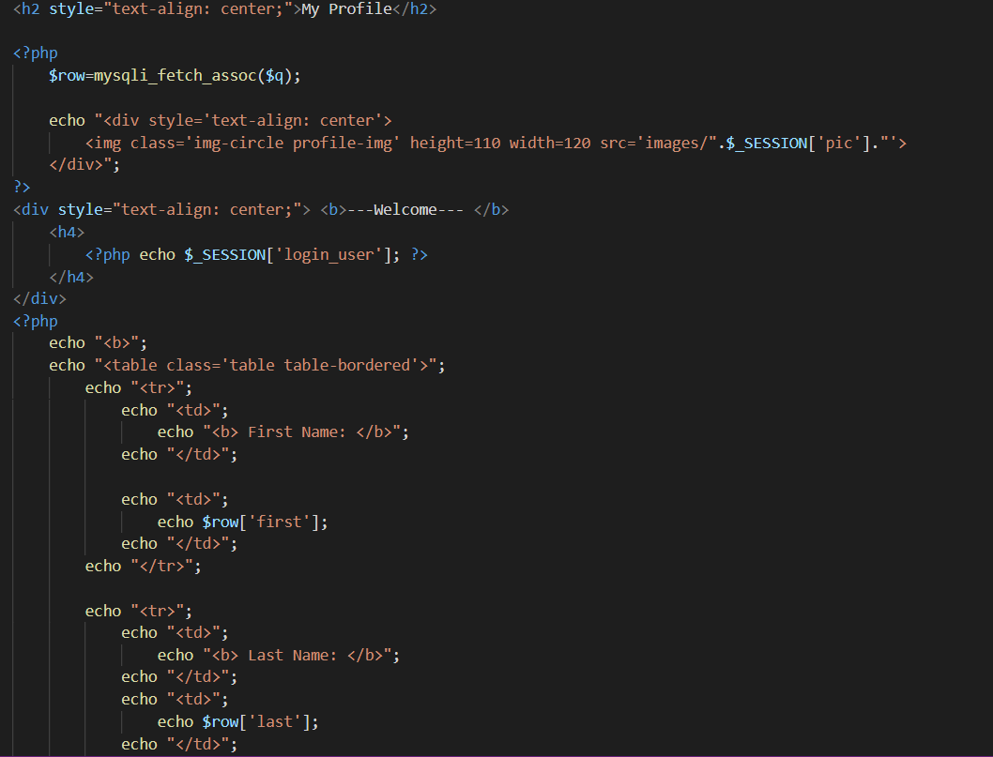

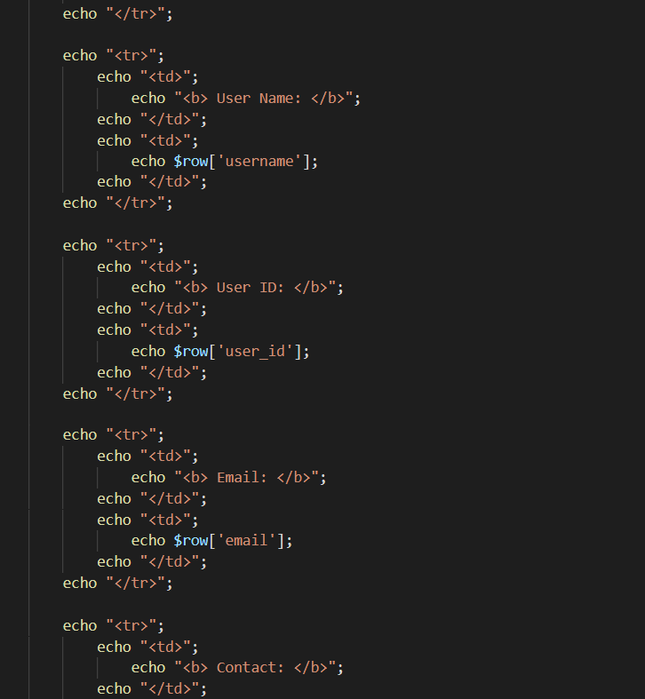

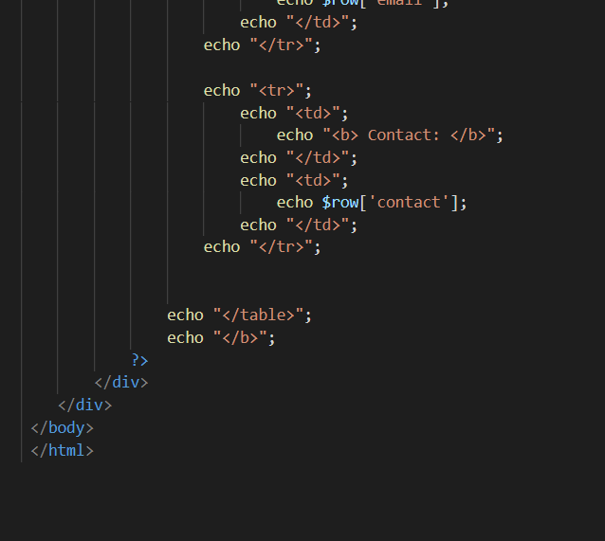

**REGISTRATION.PHP**

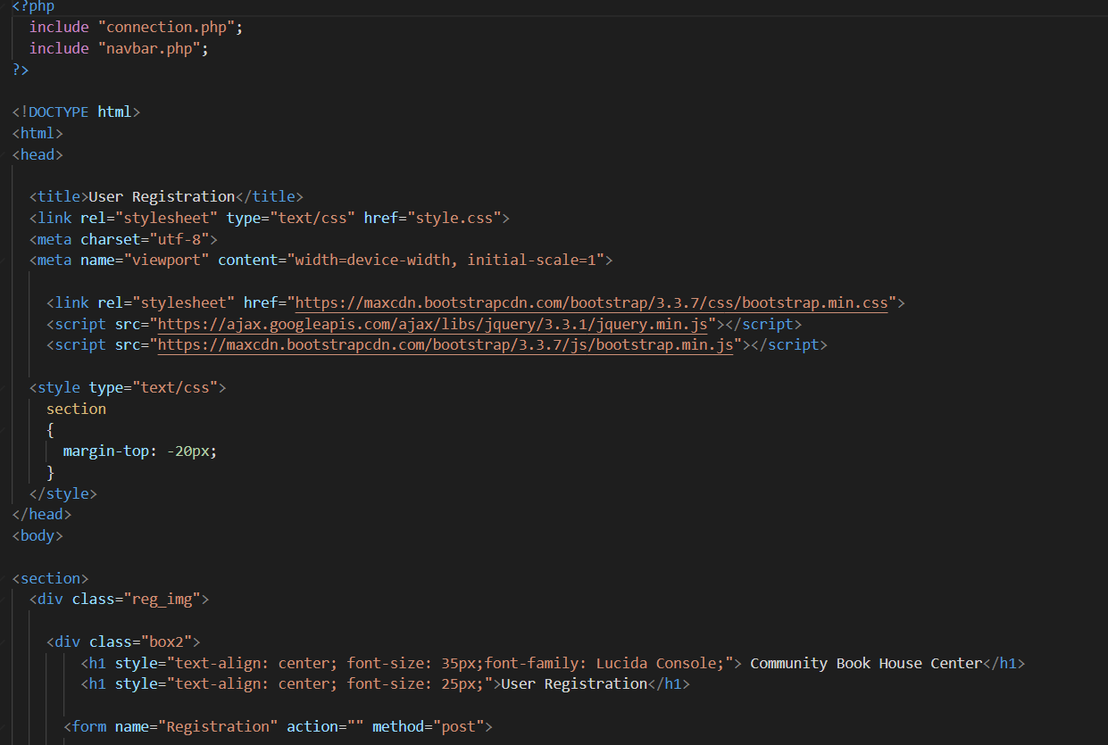

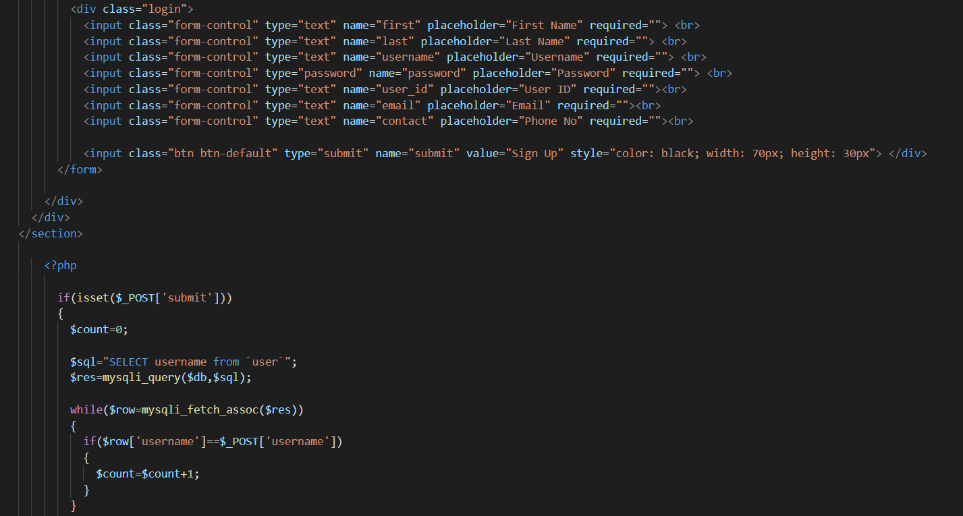

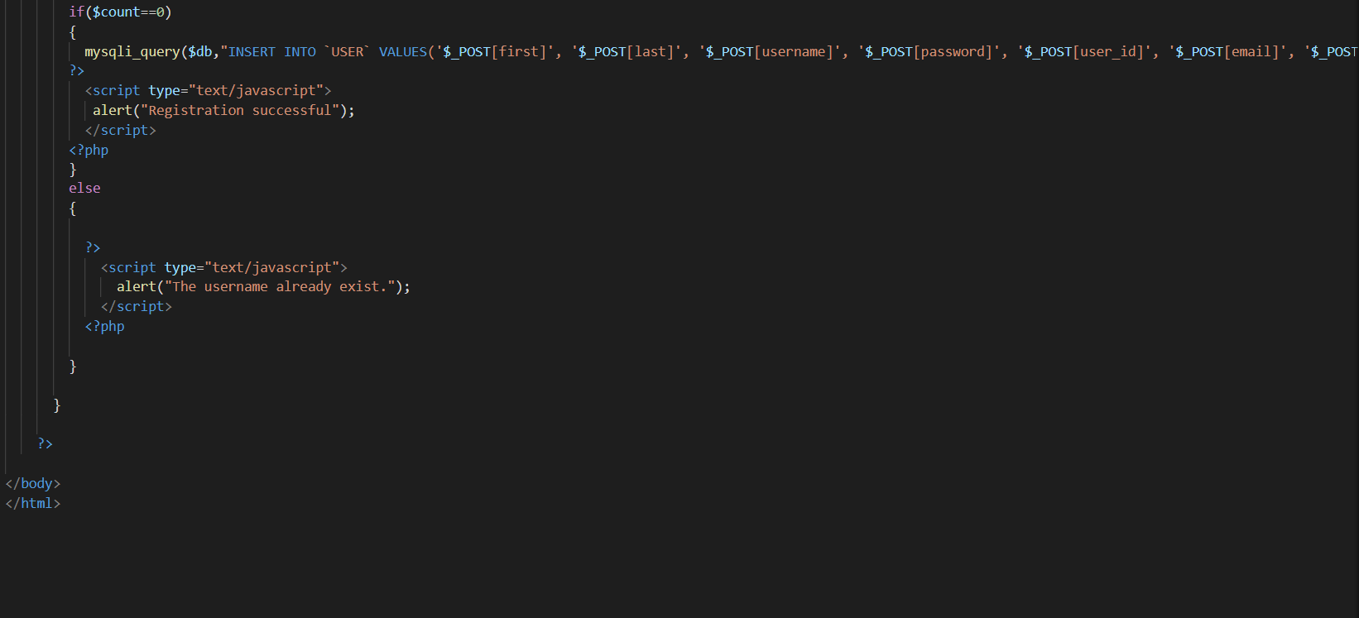

**USER-LOGIN.PHP**

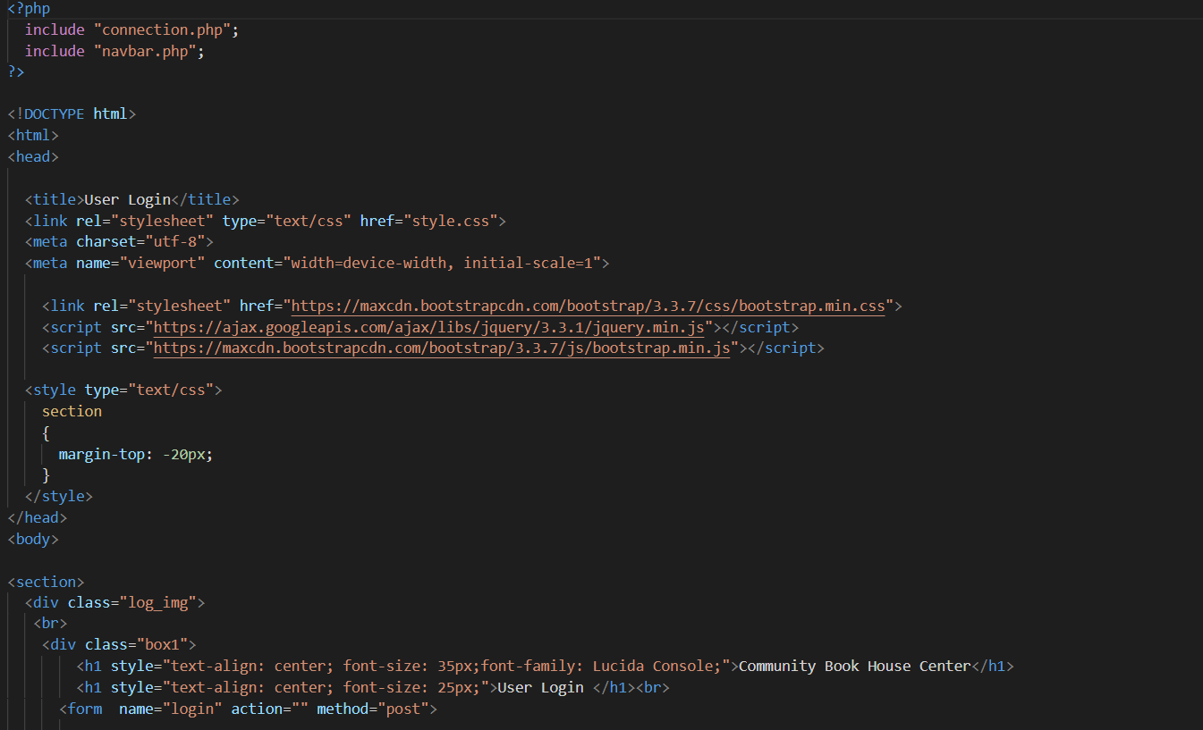

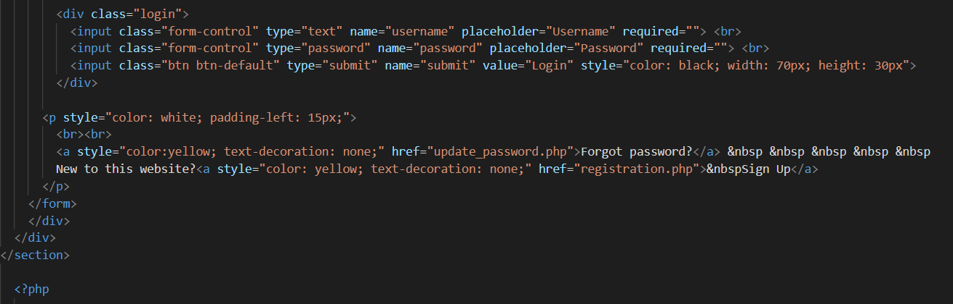

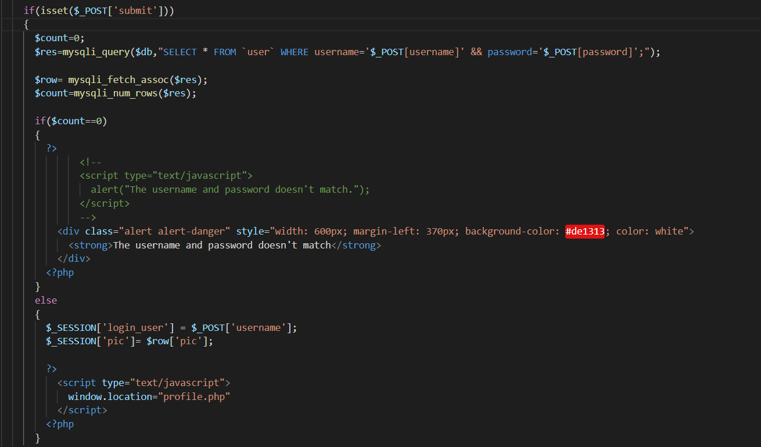

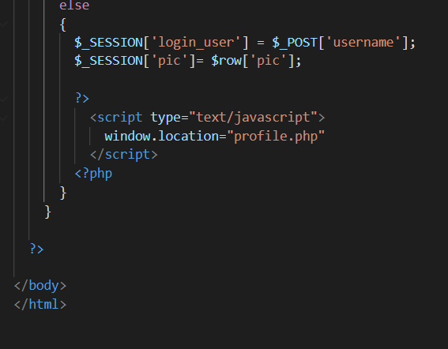

**UPDATE_PASSWORD.PHP**

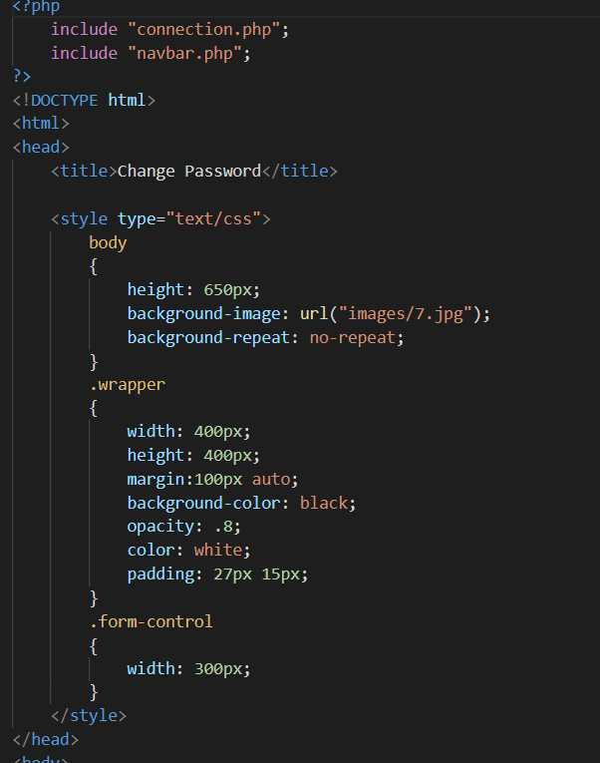

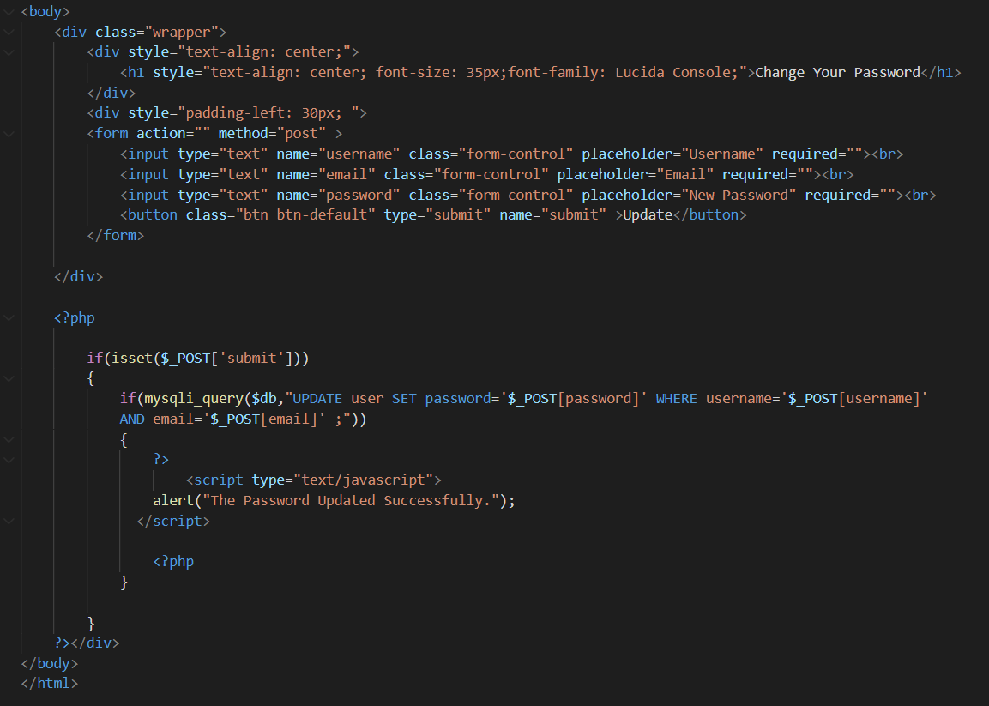

**INDEX.PHP**

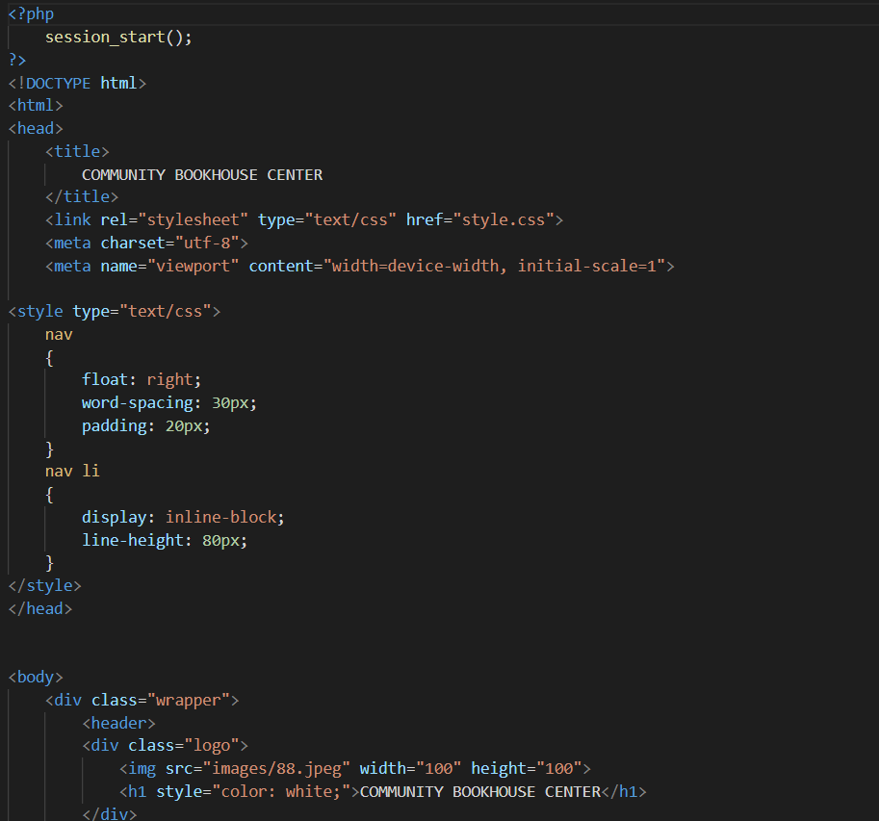

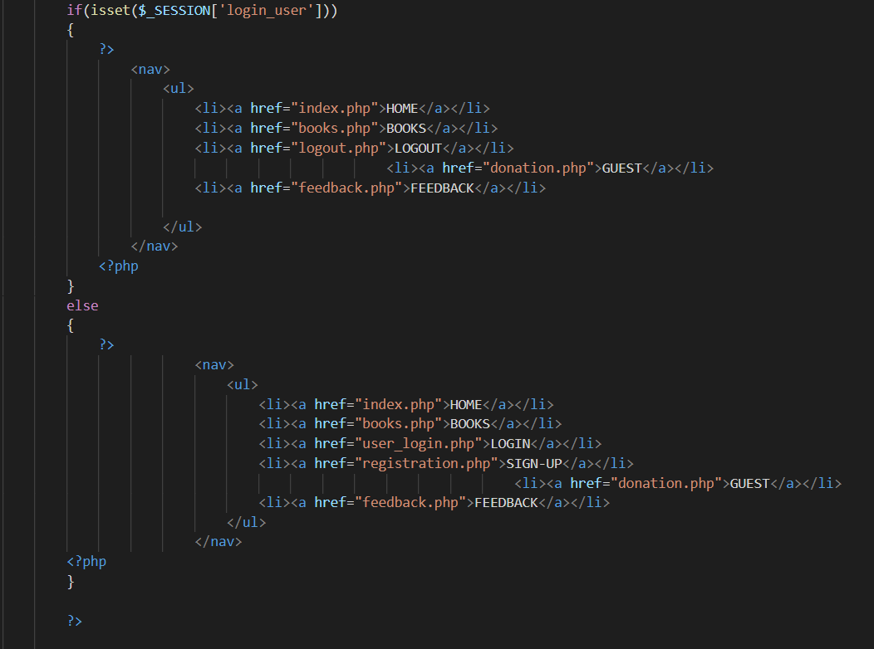

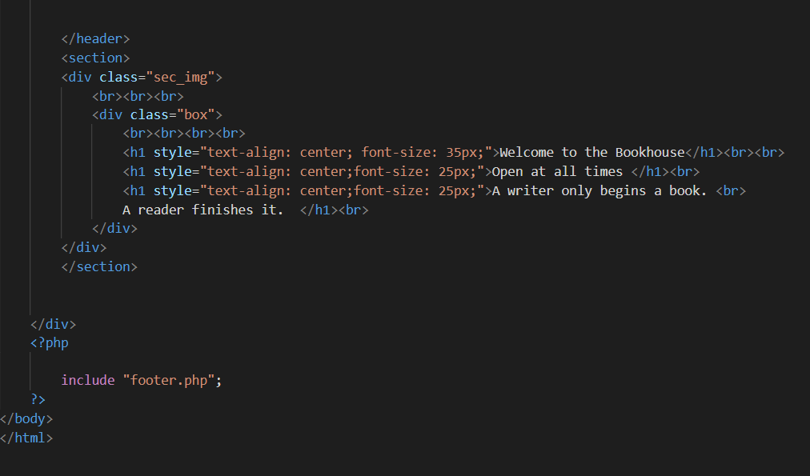

**REQUEST.PHP**

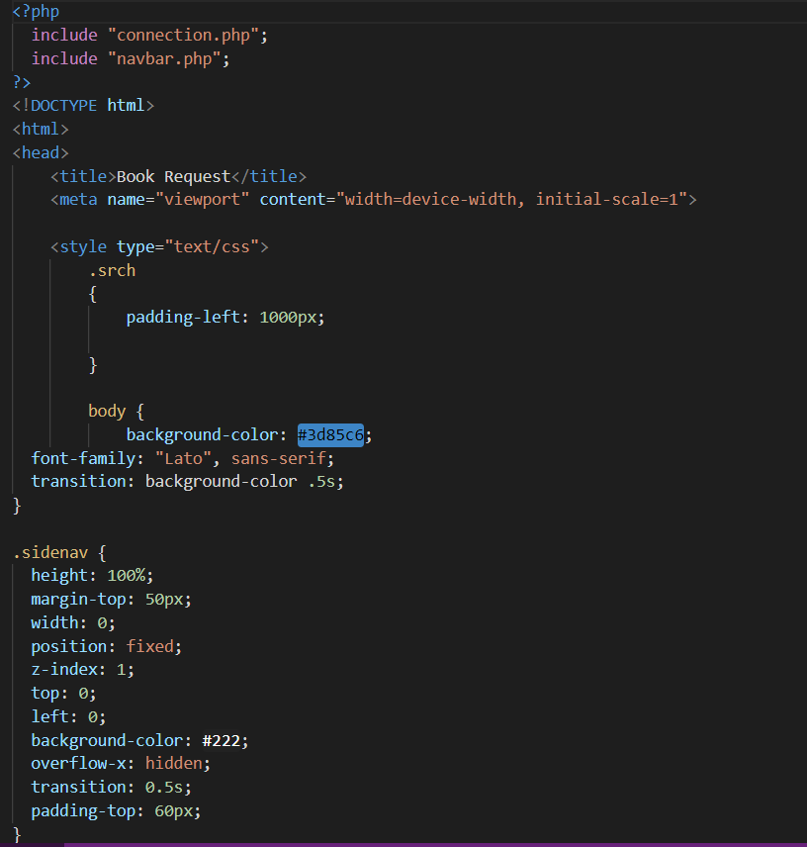

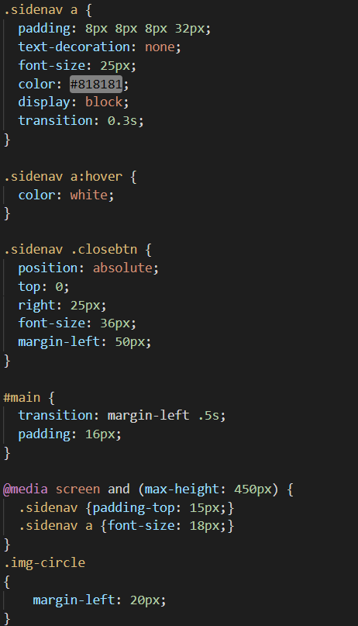

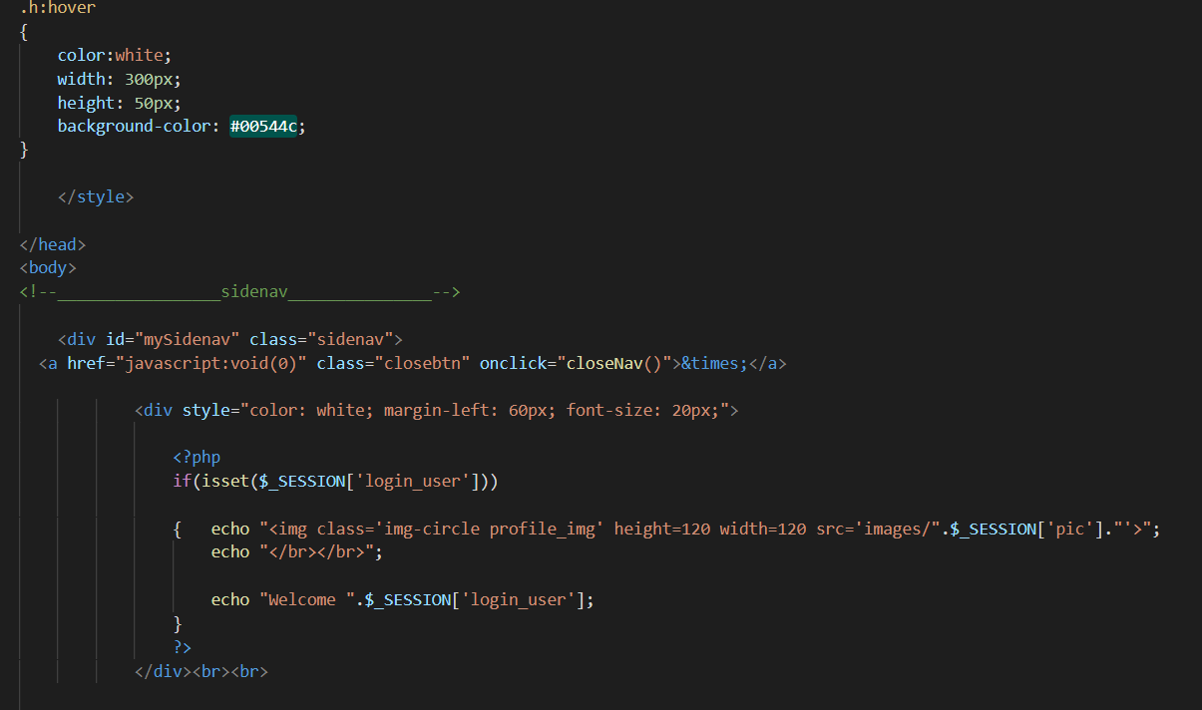

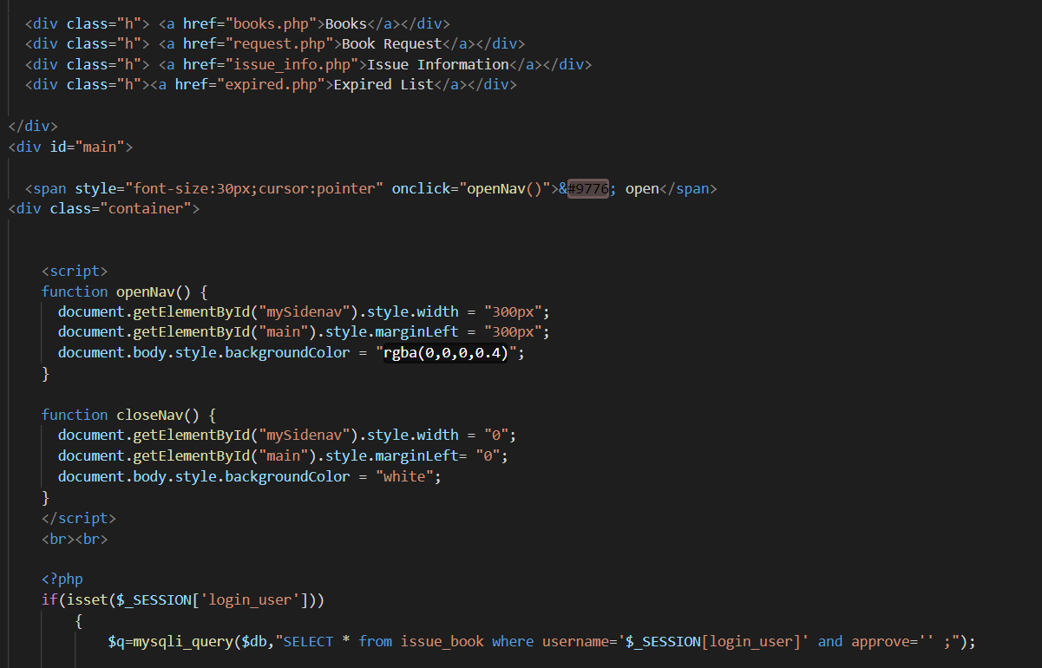

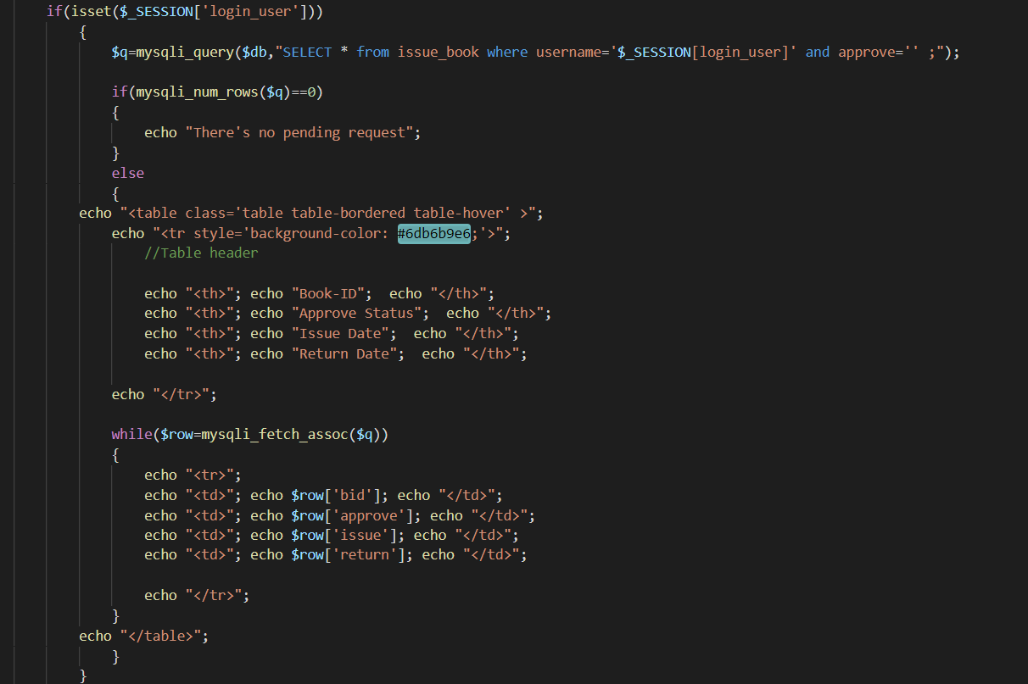

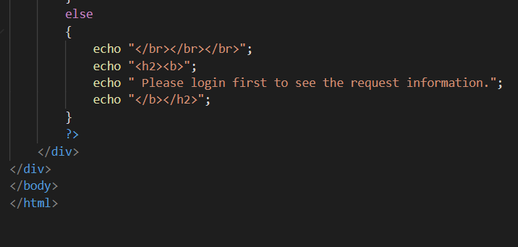

**LOGOUT.PHP**

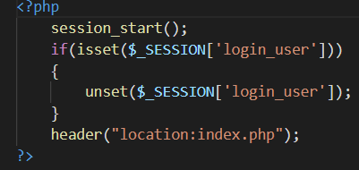

**CONNECTION.PHP**

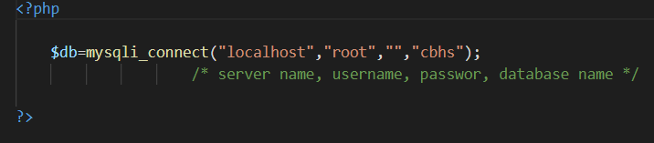

**STYLES.CSS**

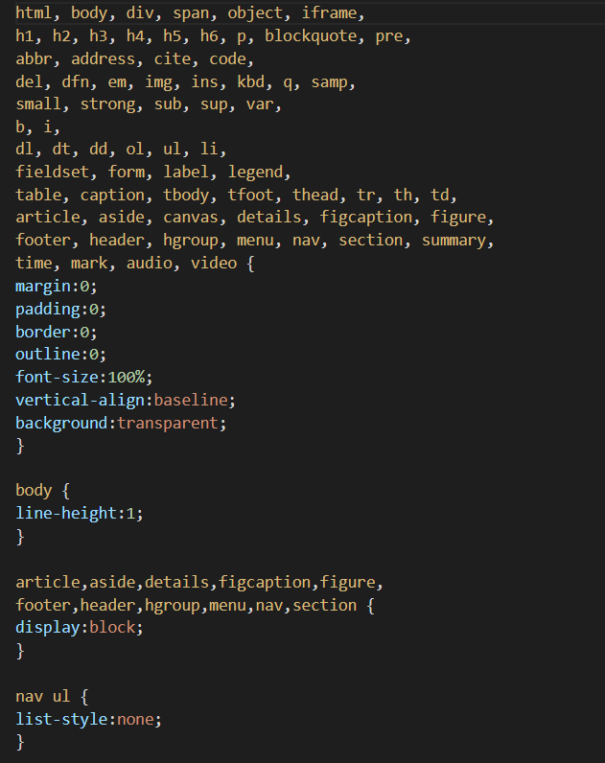

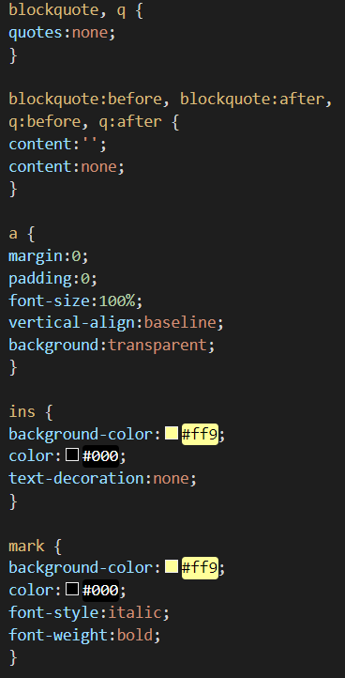

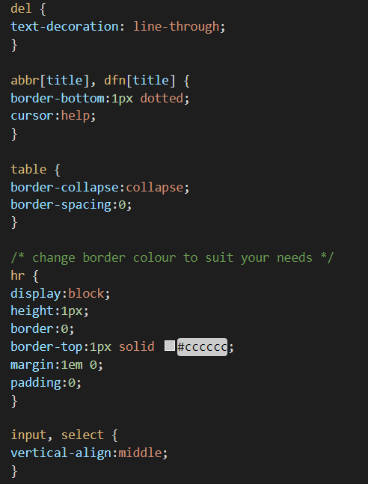

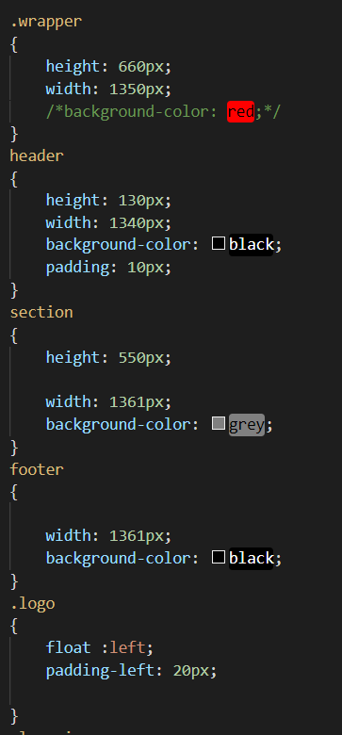

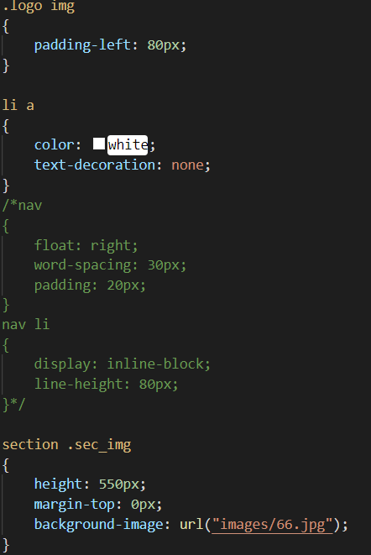

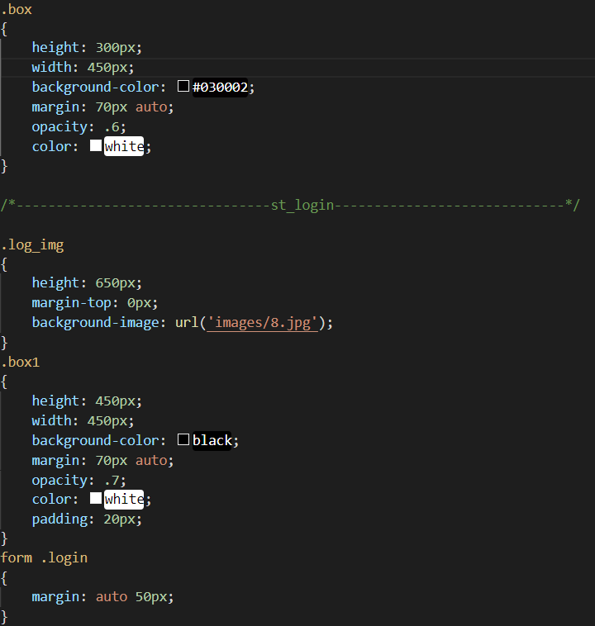

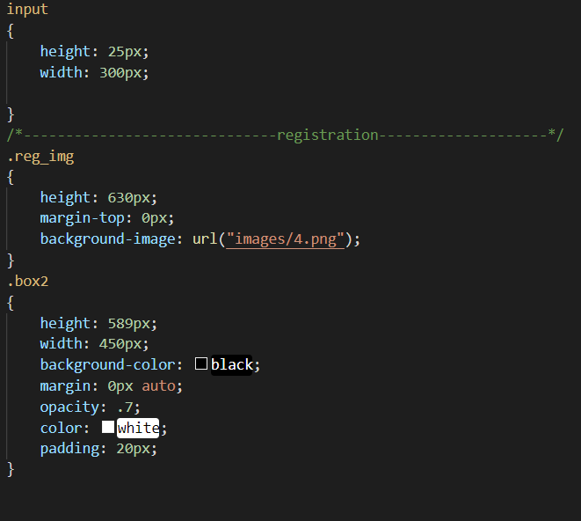

**ADMIN**

**PROFILE.PHP**

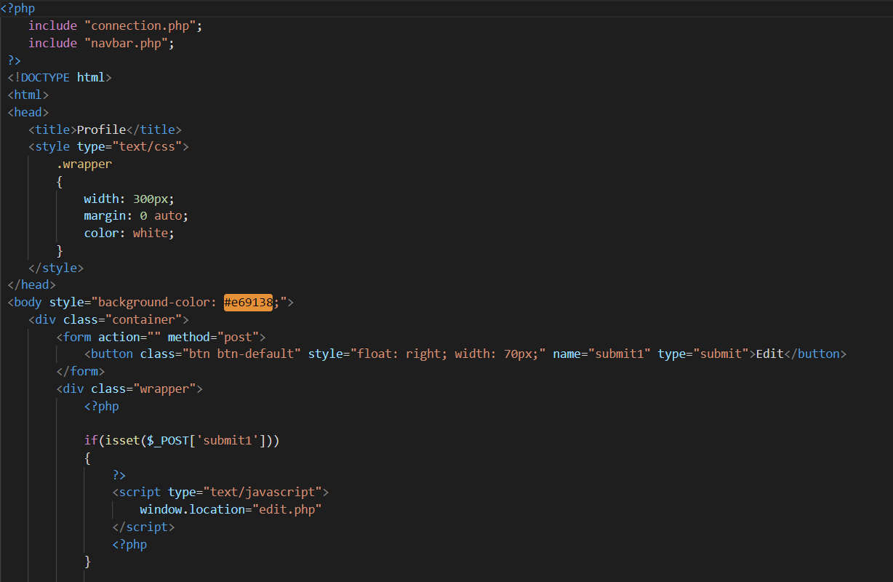

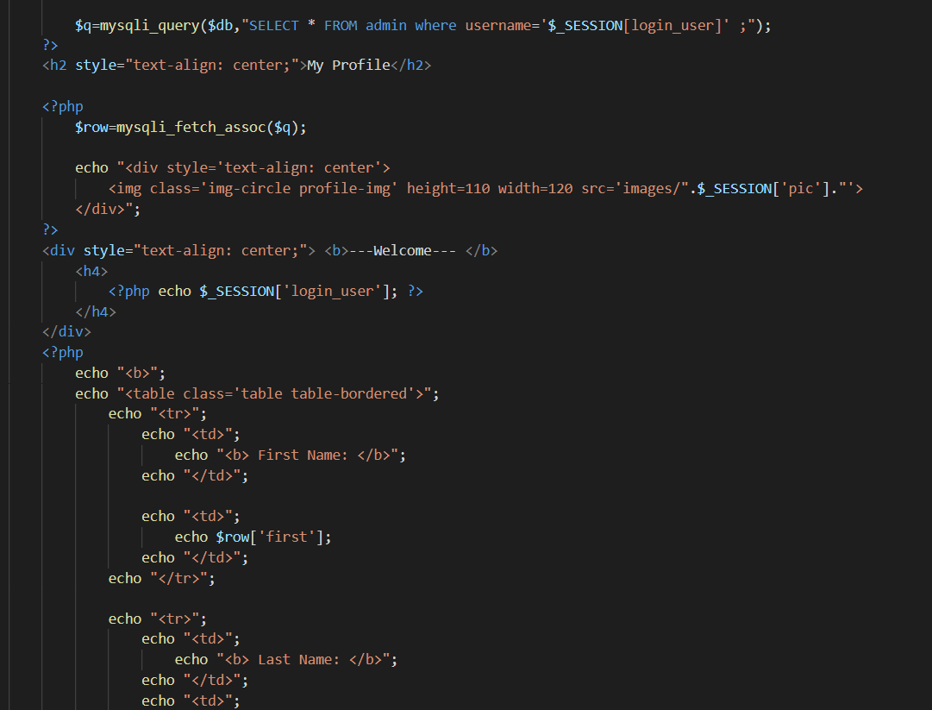

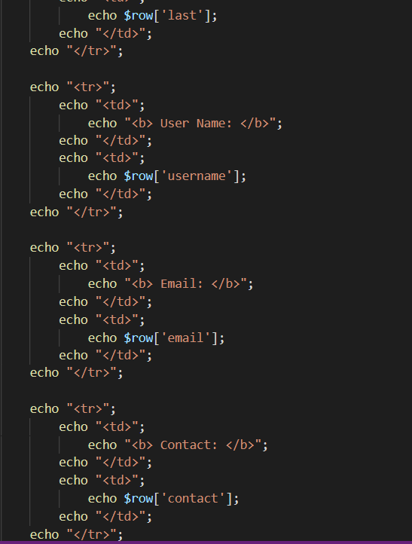

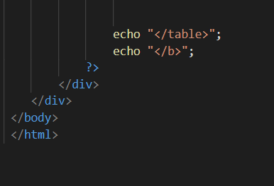

**REGISTRATION.PHP**

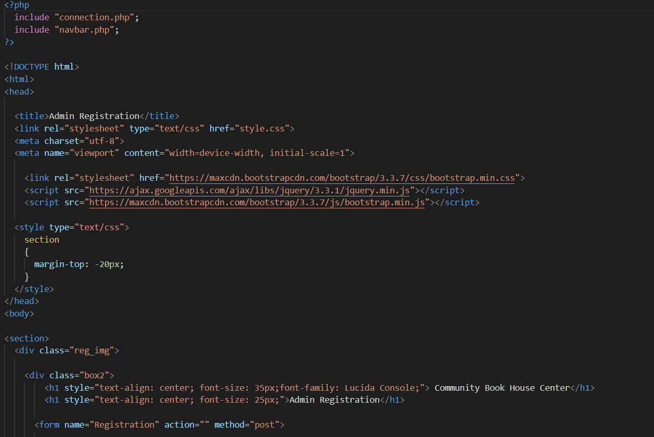

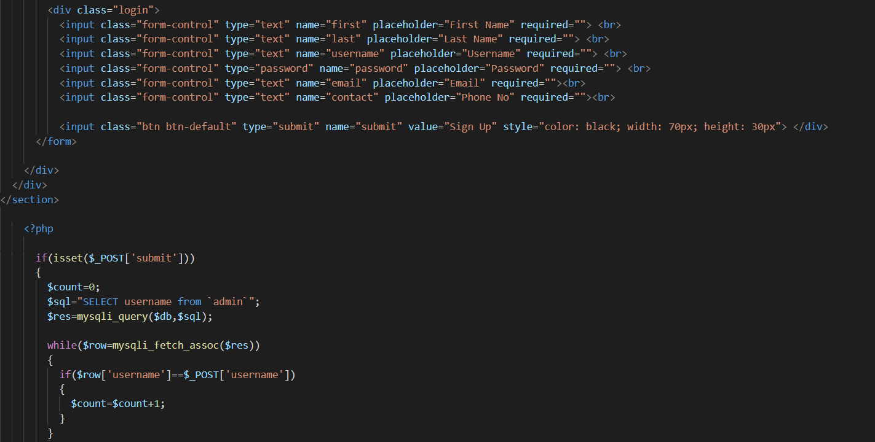

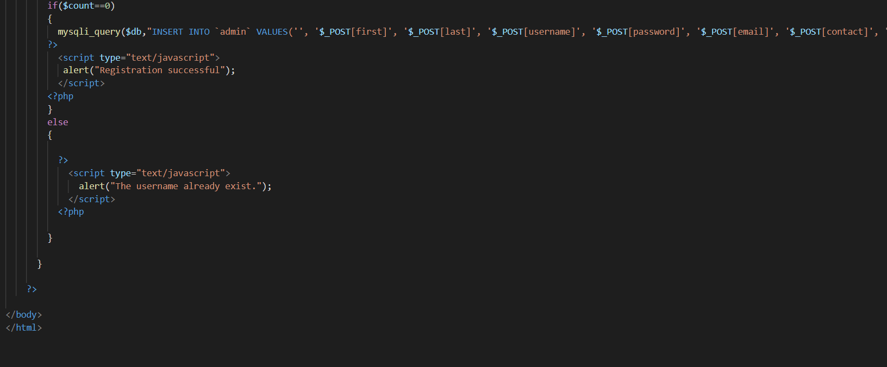

**USER.PHP**

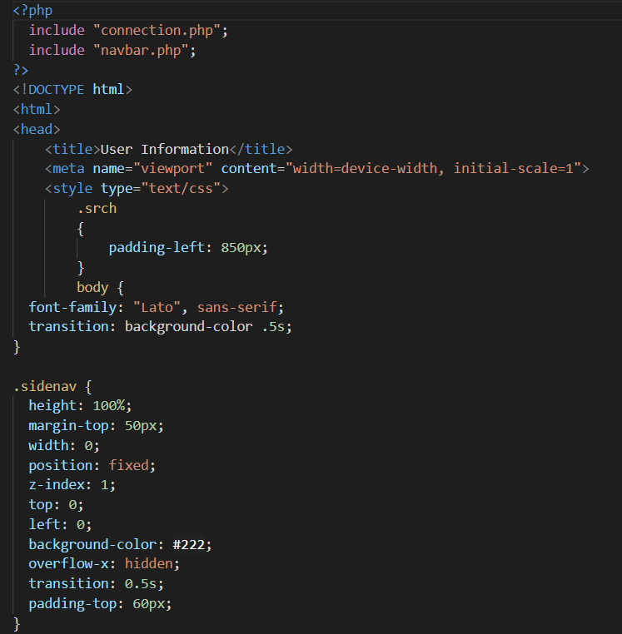

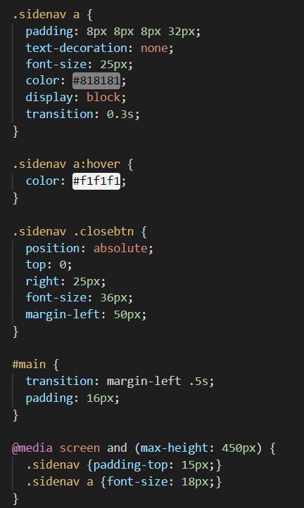

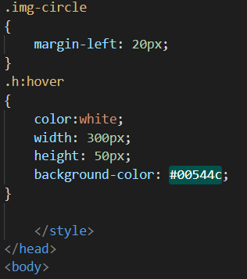

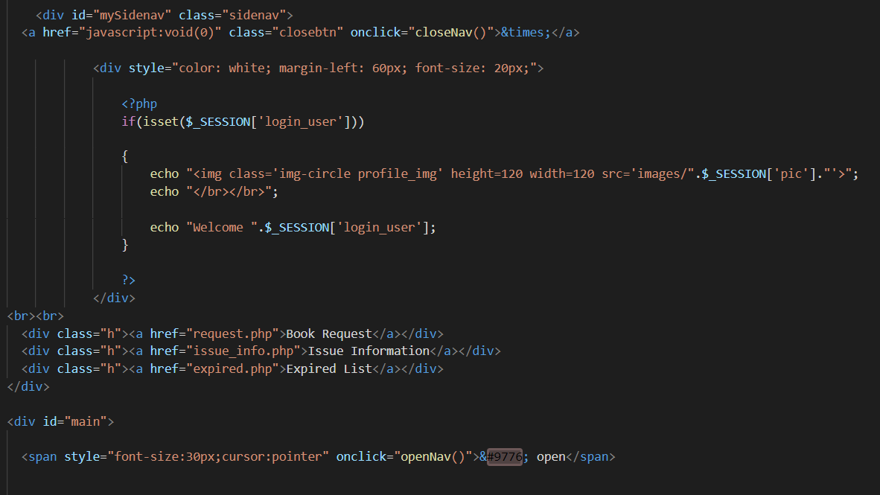

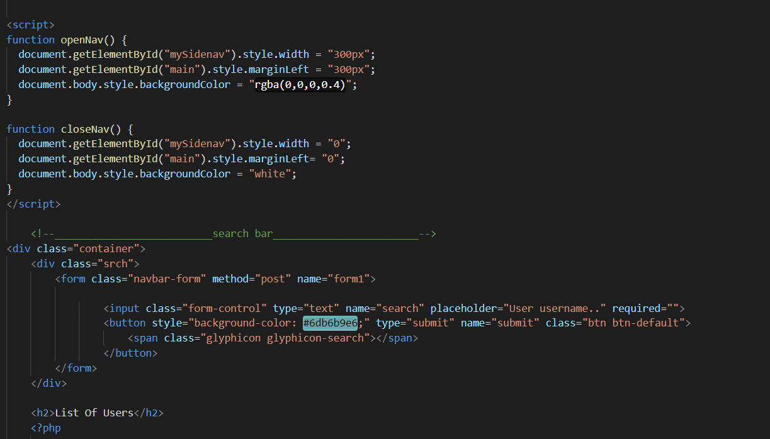

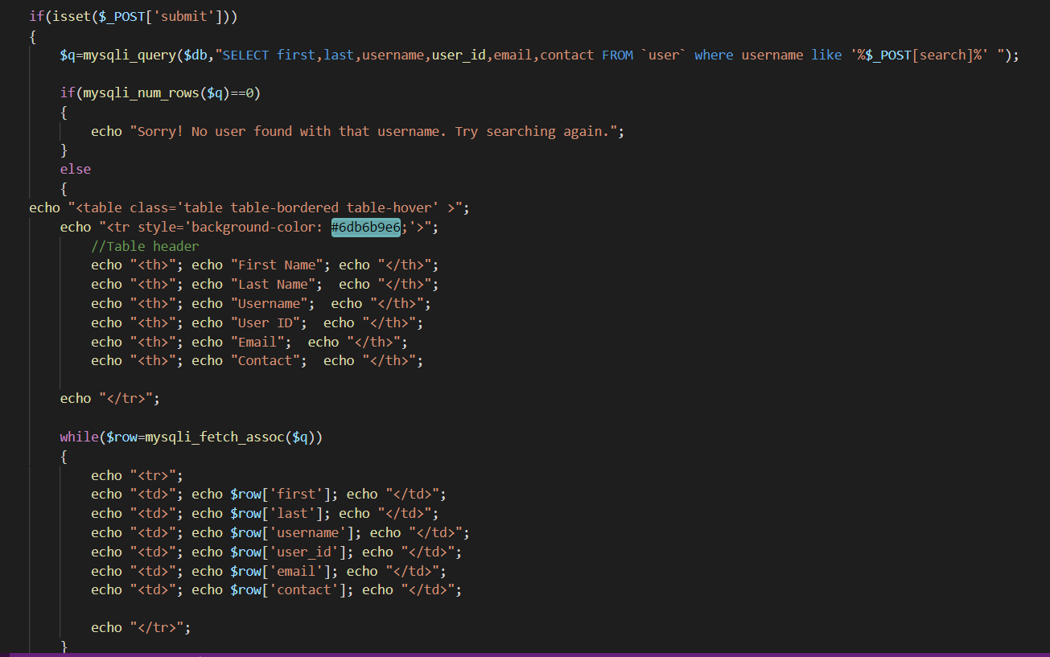

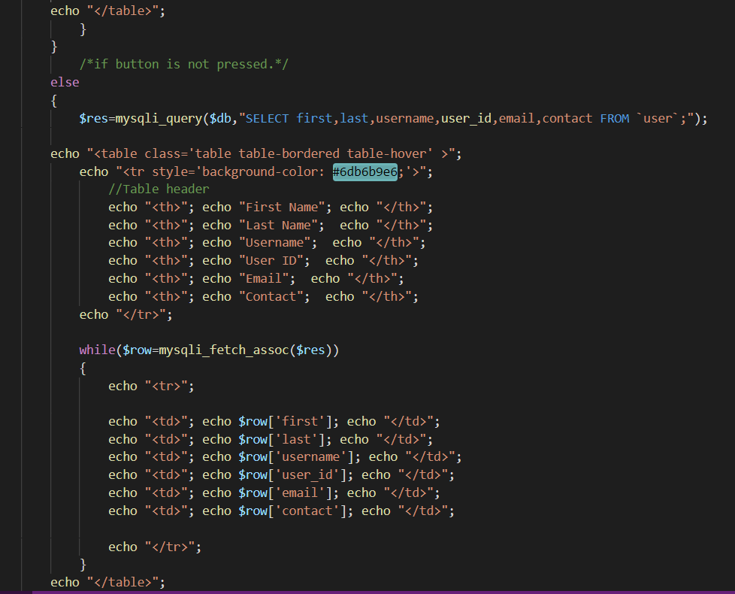

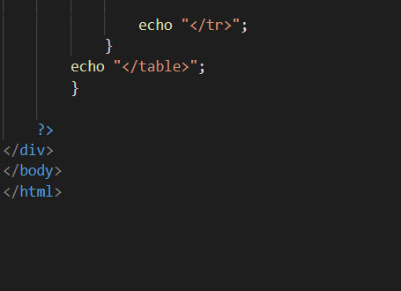

**ADMIN_LOGIN.PHP**

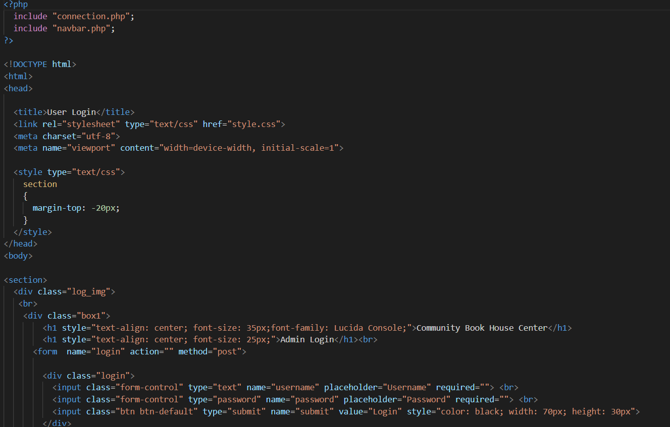

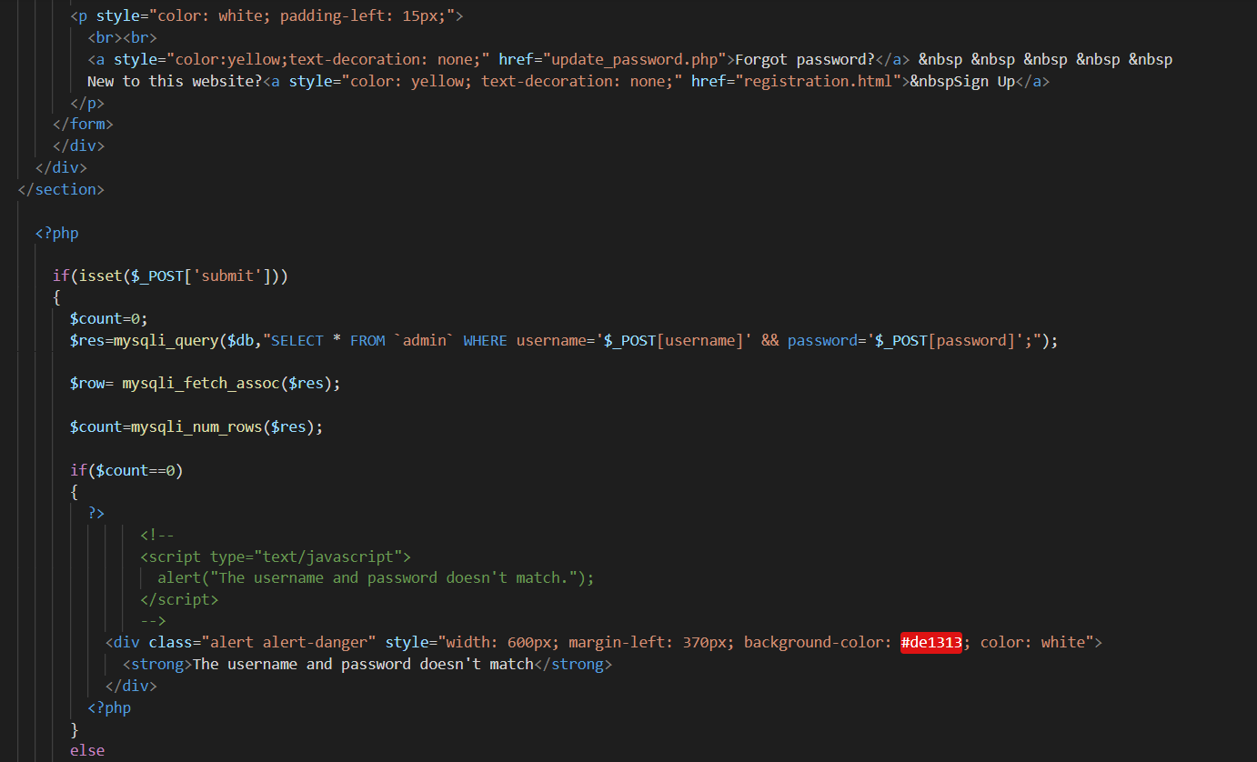

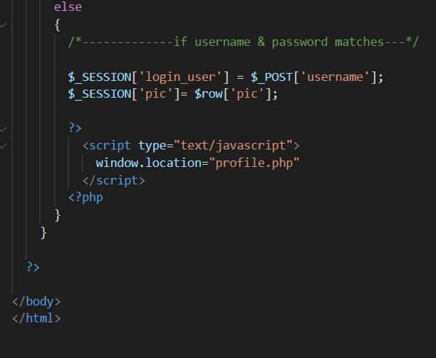

**ADD.PHP**

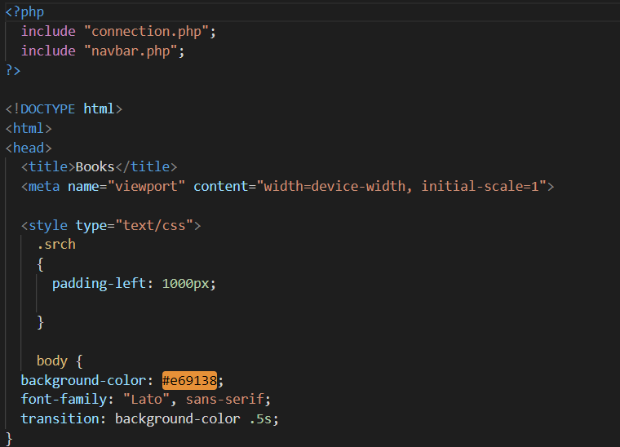

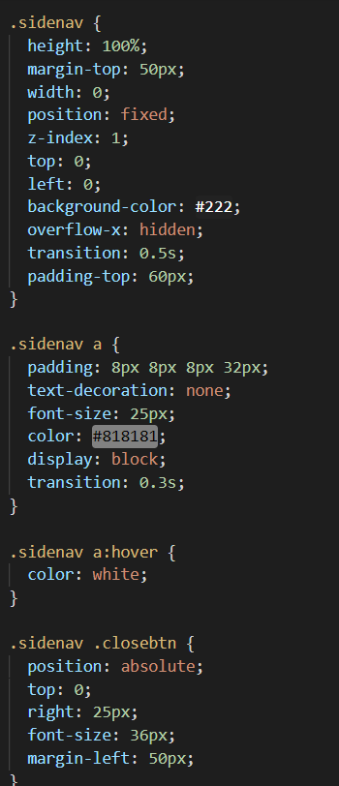

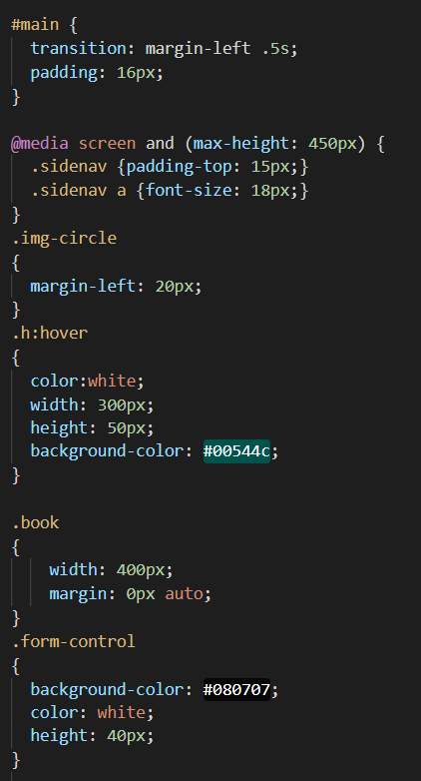

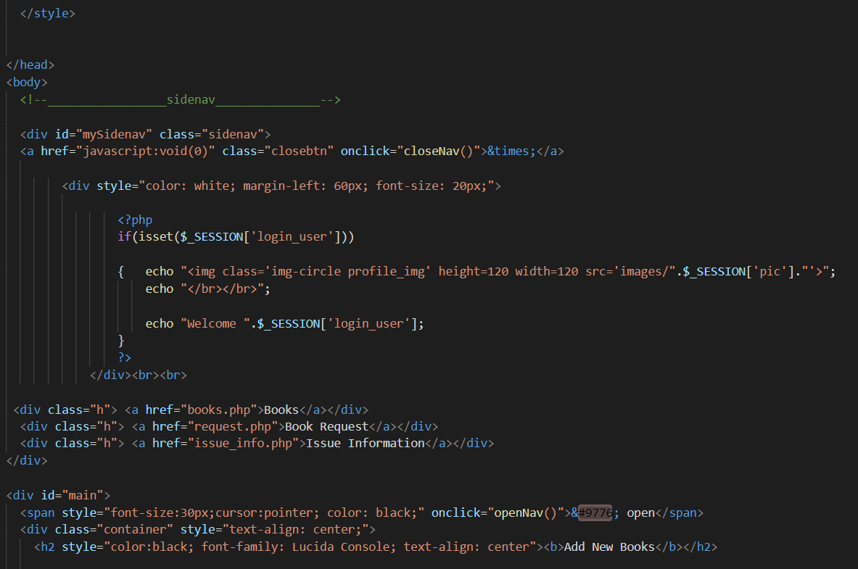

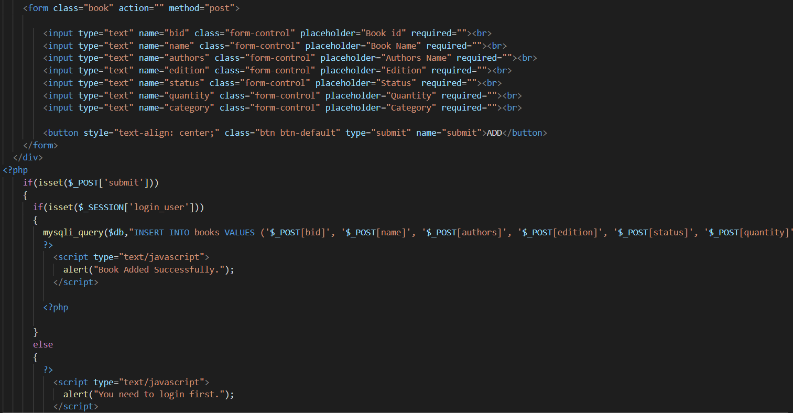

**BOOKS**

**BOOKS.PHP**

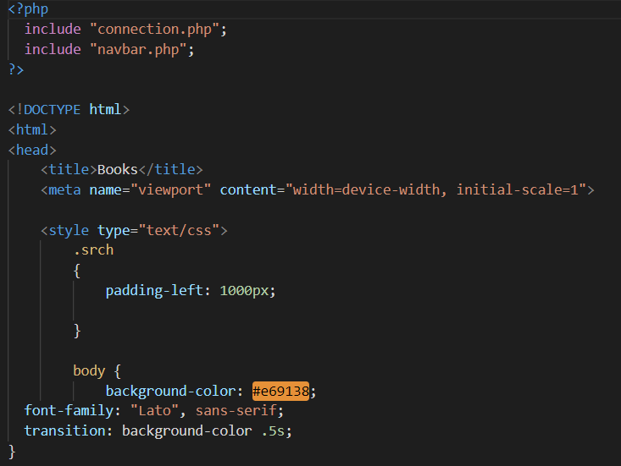

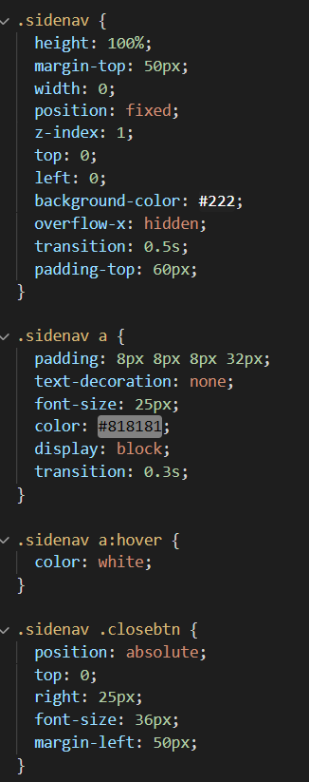

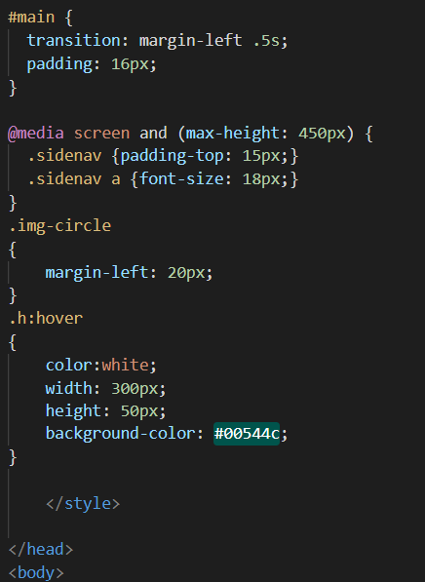

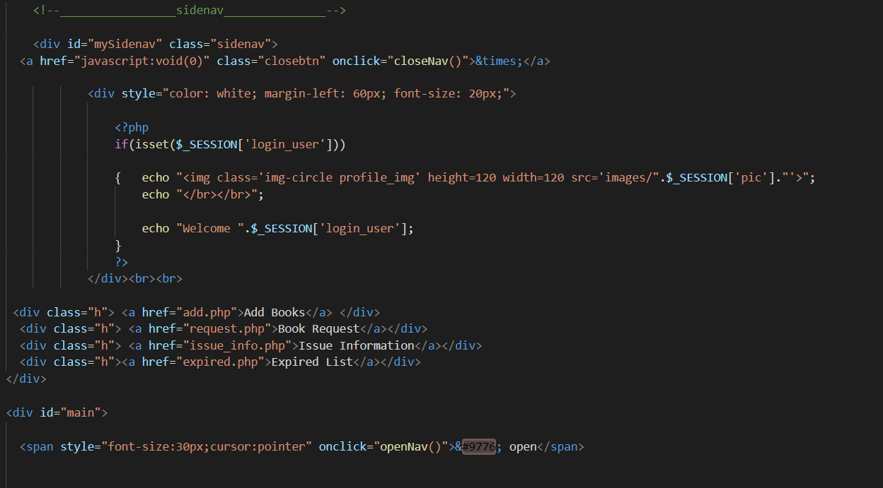

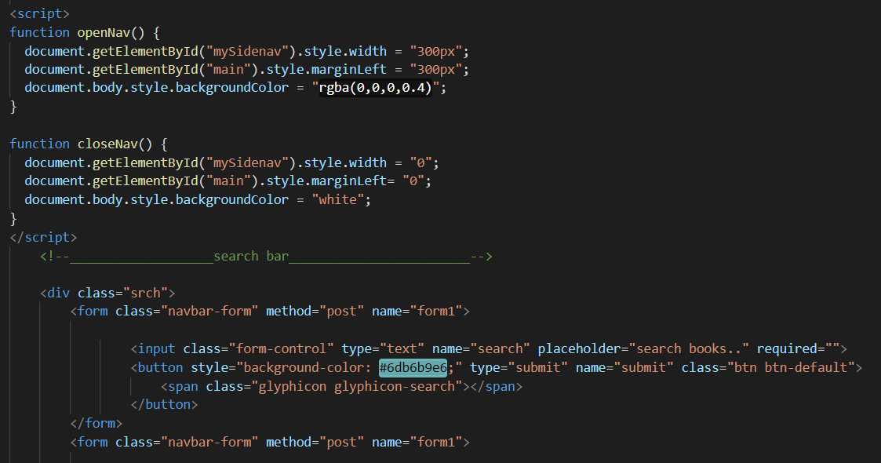

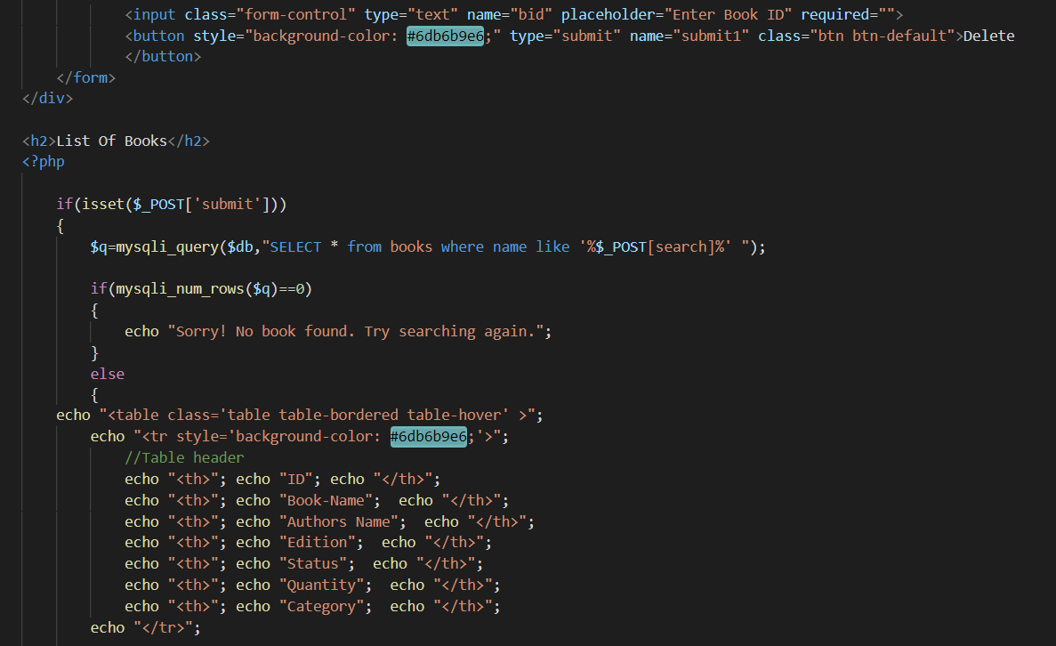

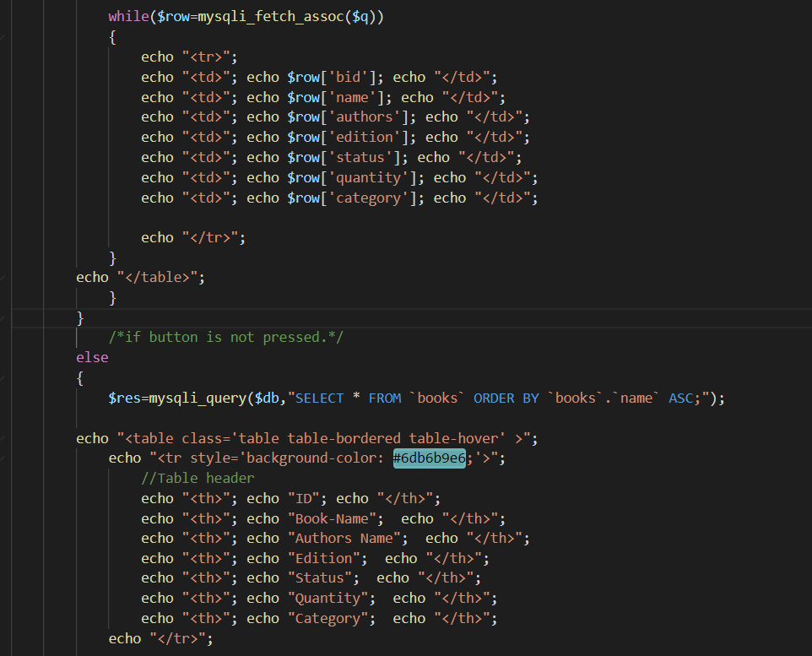

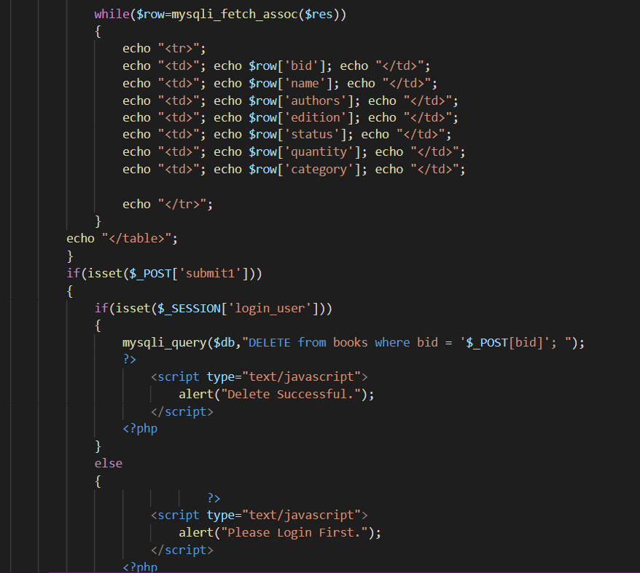

**FEEDBACK**

**FEEDBACK.PHP**

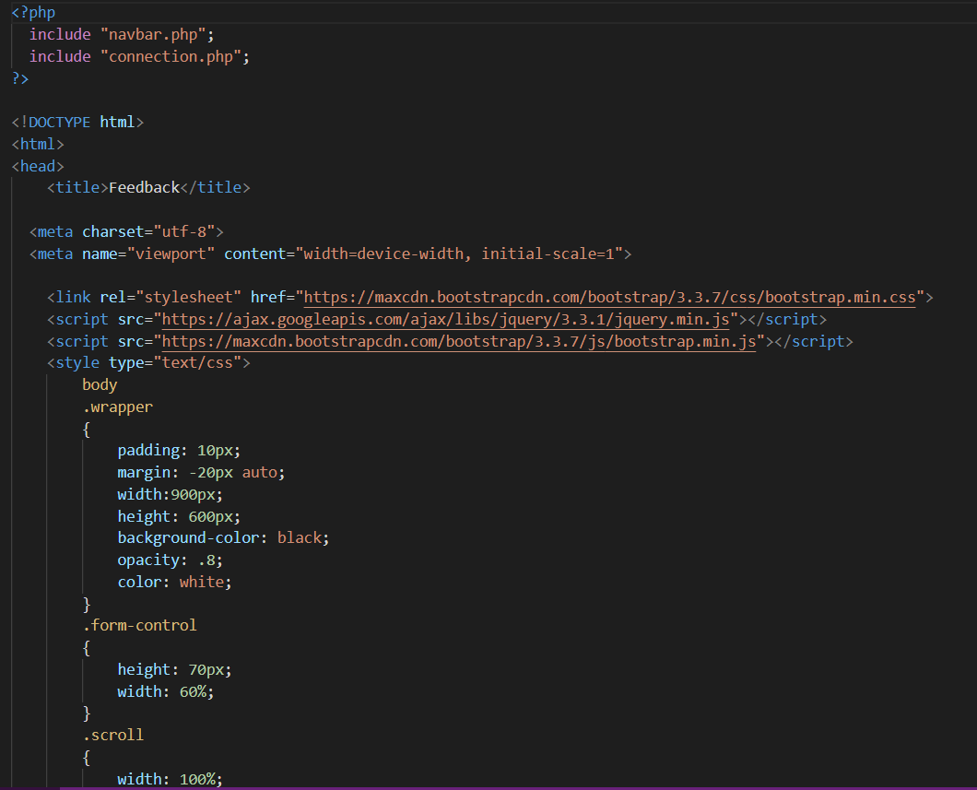

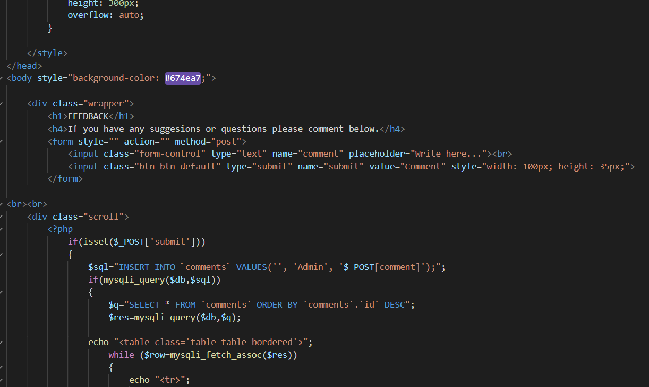

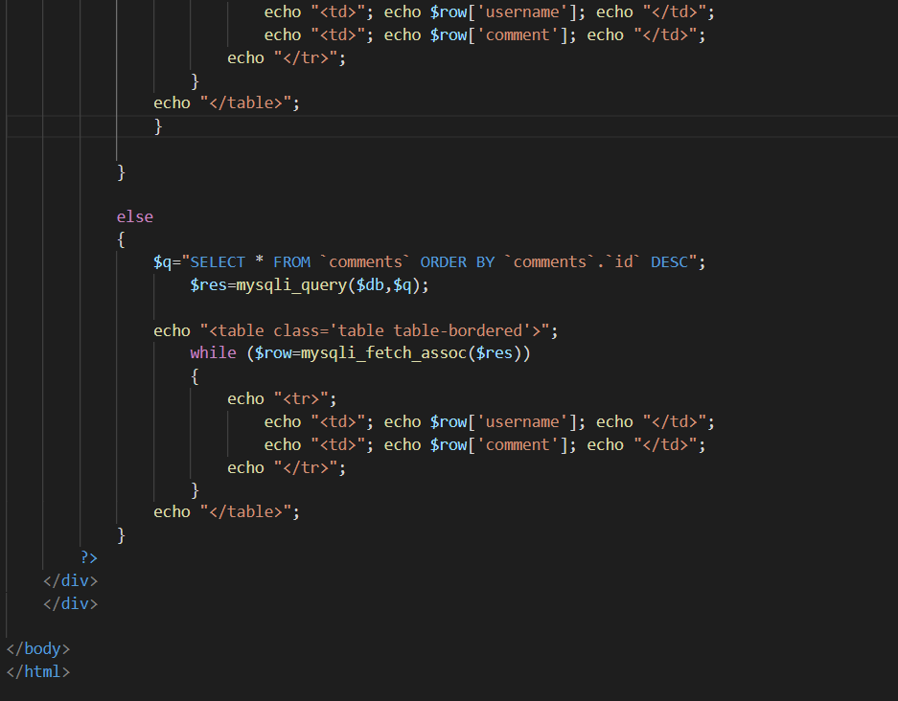

**DATABASE**

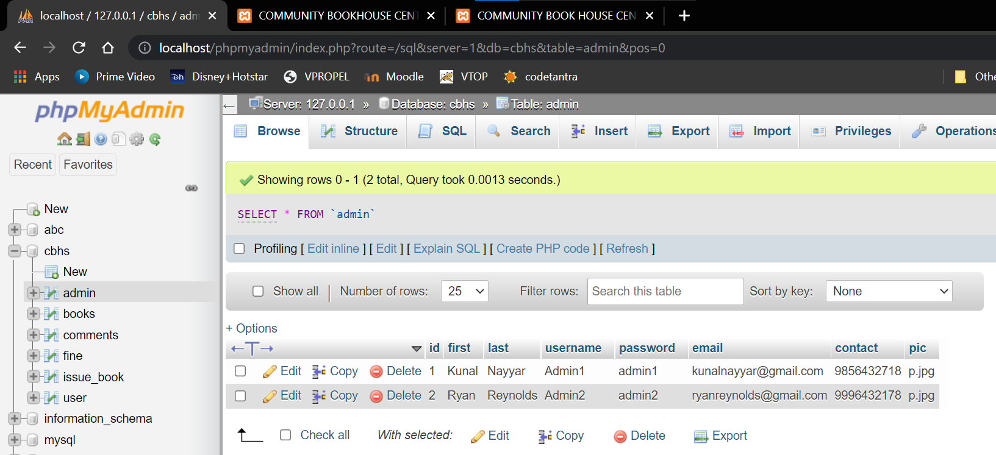

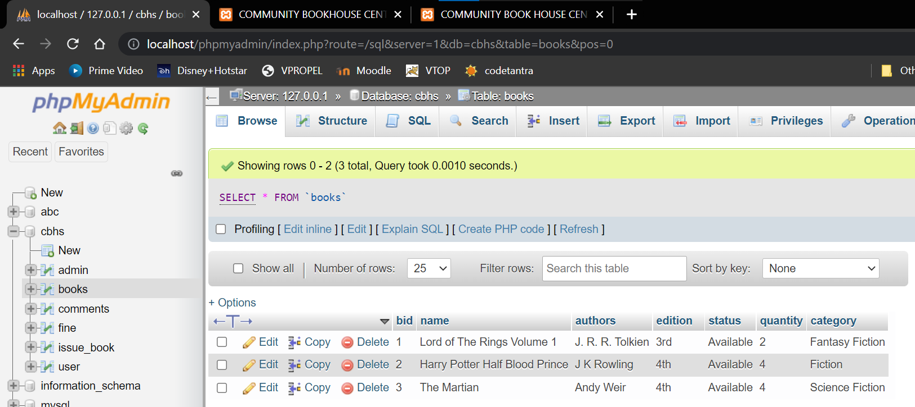

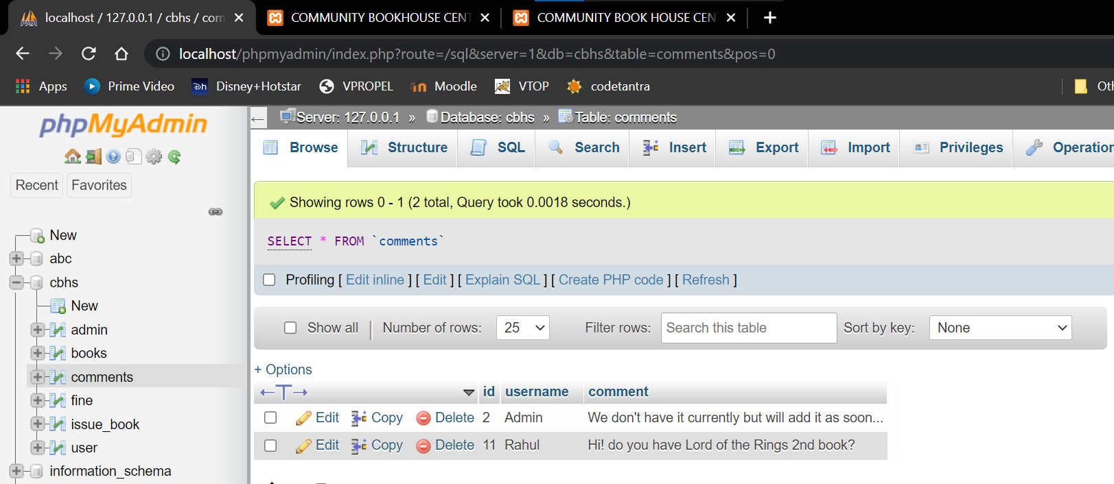

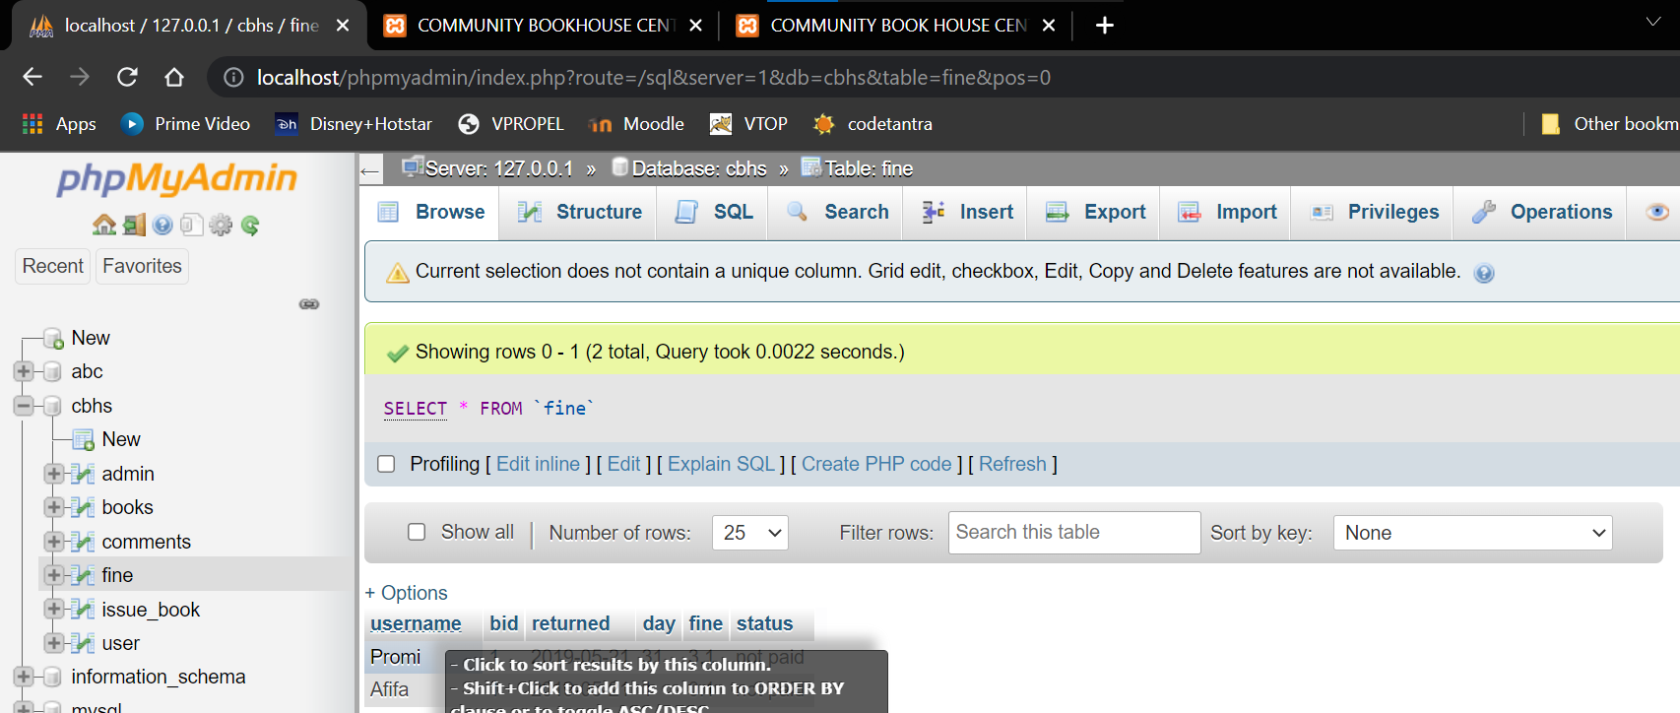

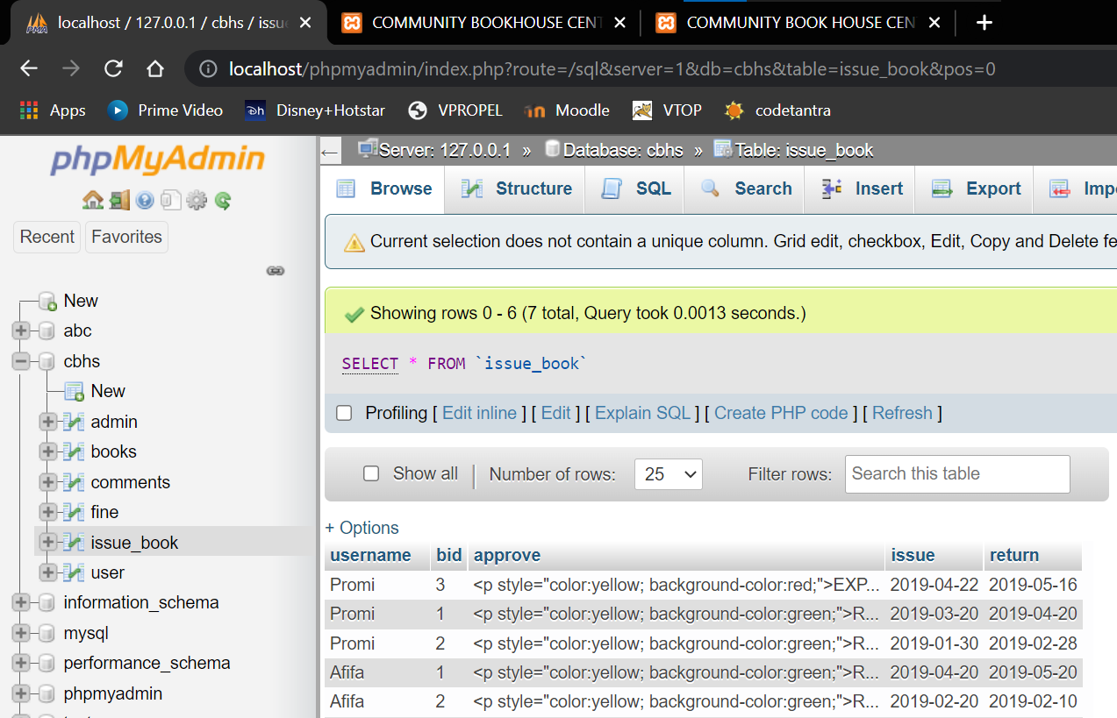

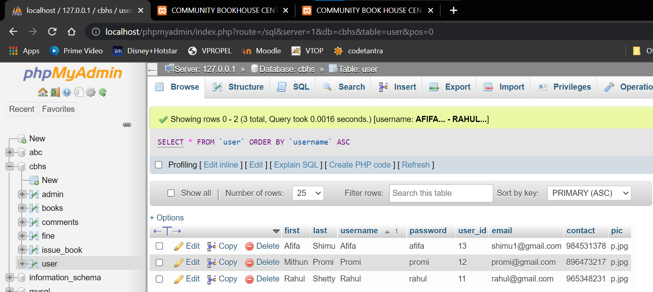

**WEBSITE**

**User Home Page**

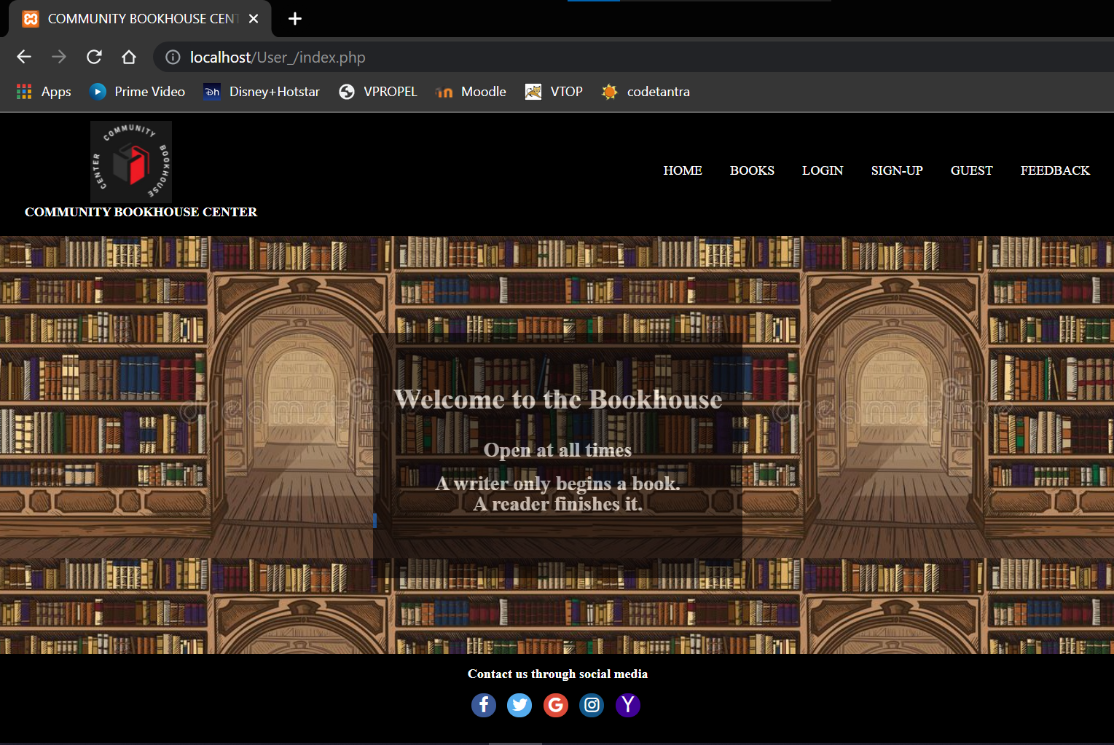

**User Login**

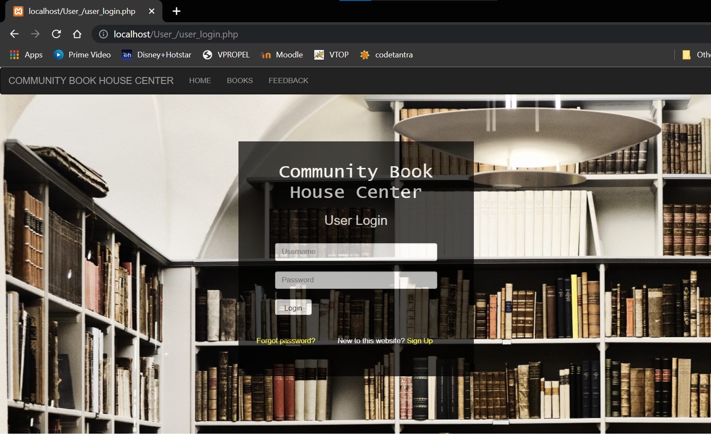

**Registration**

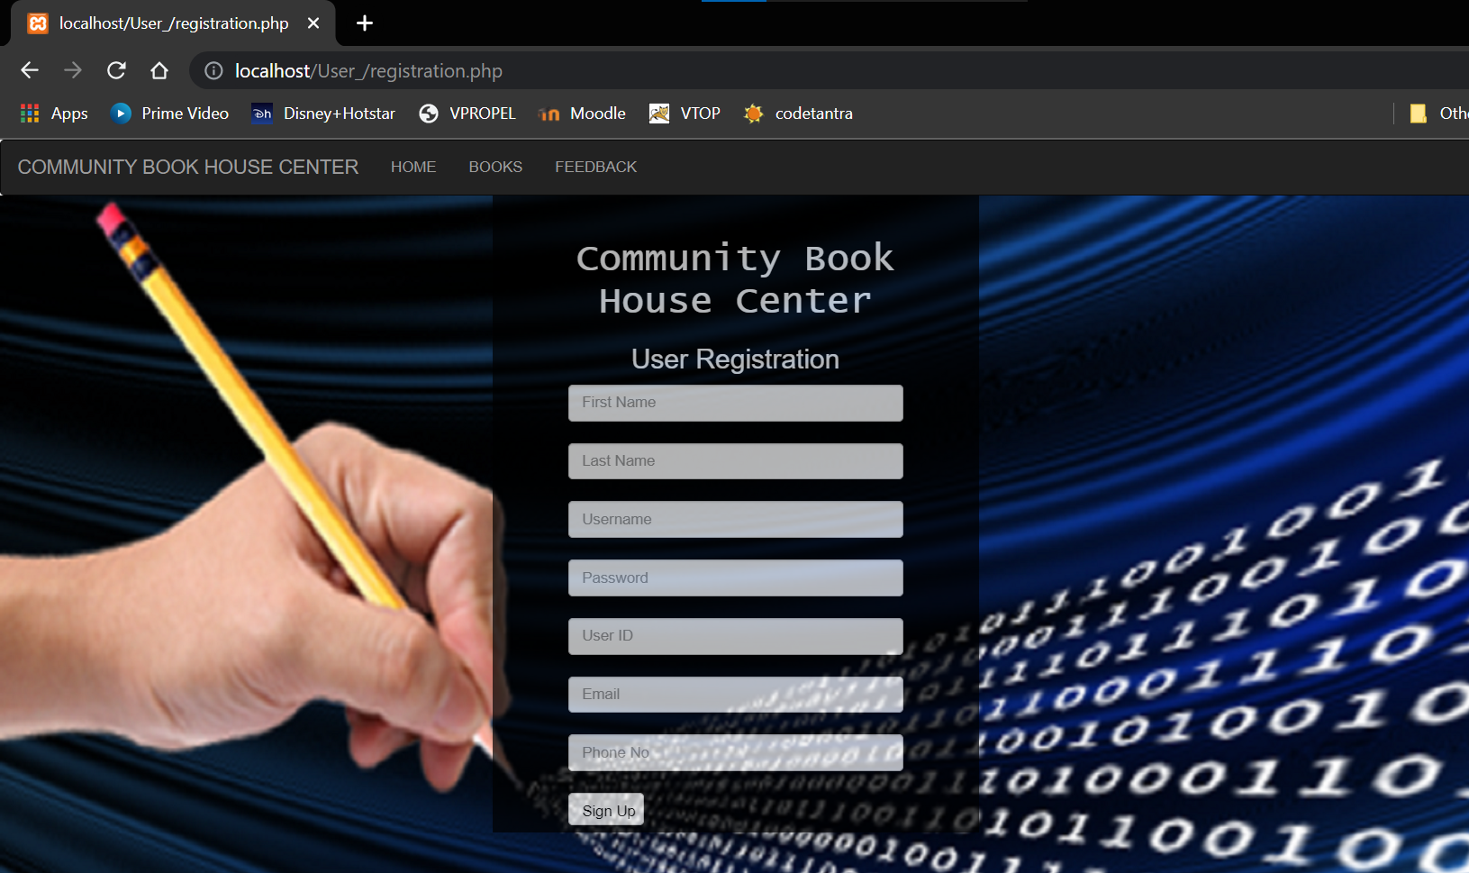

**Profile**

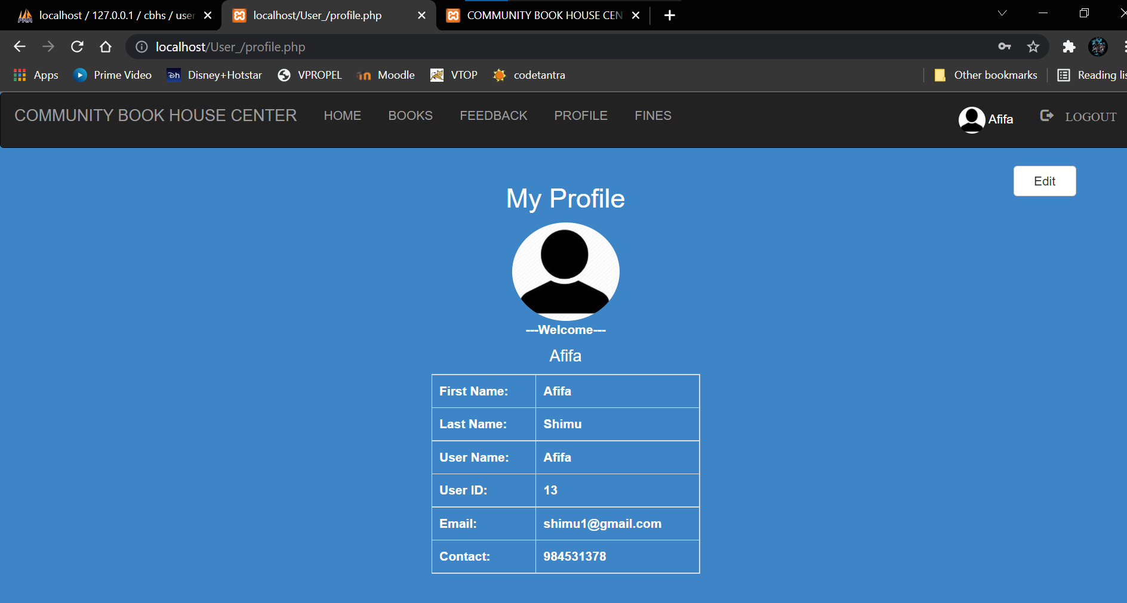

**Book List   
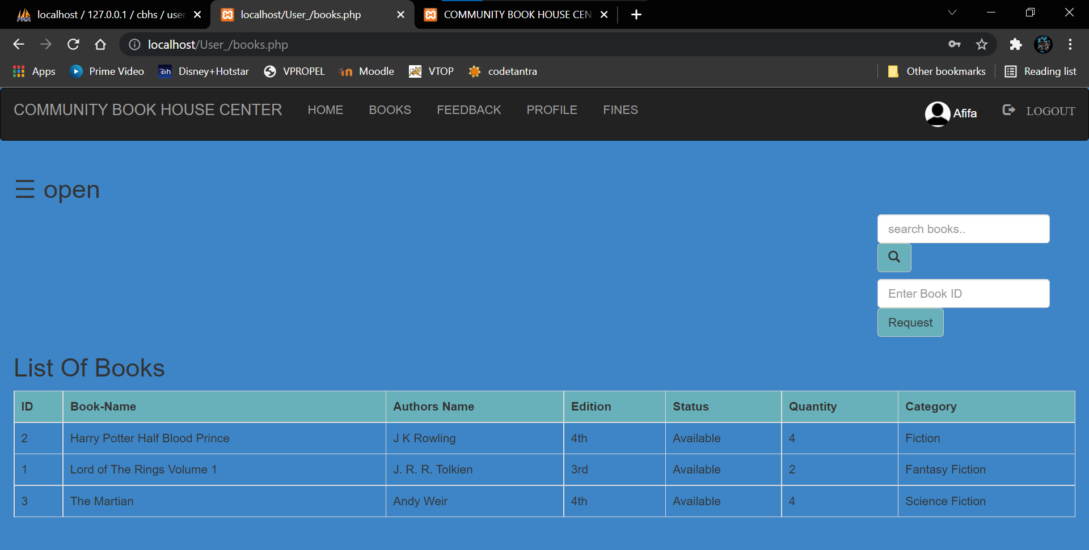**

**Issue Information   
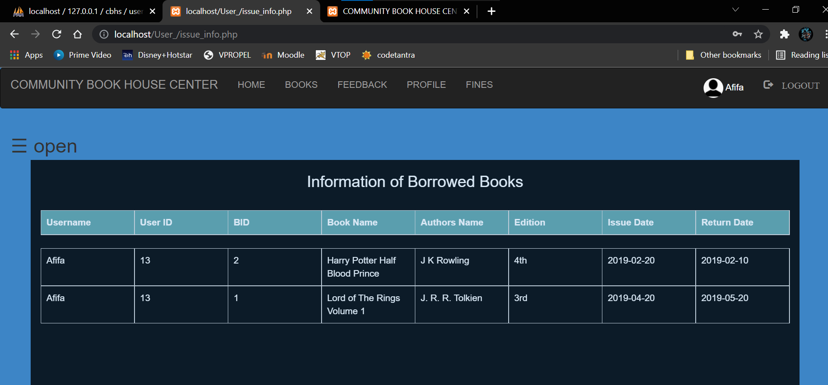**

**Expired List   
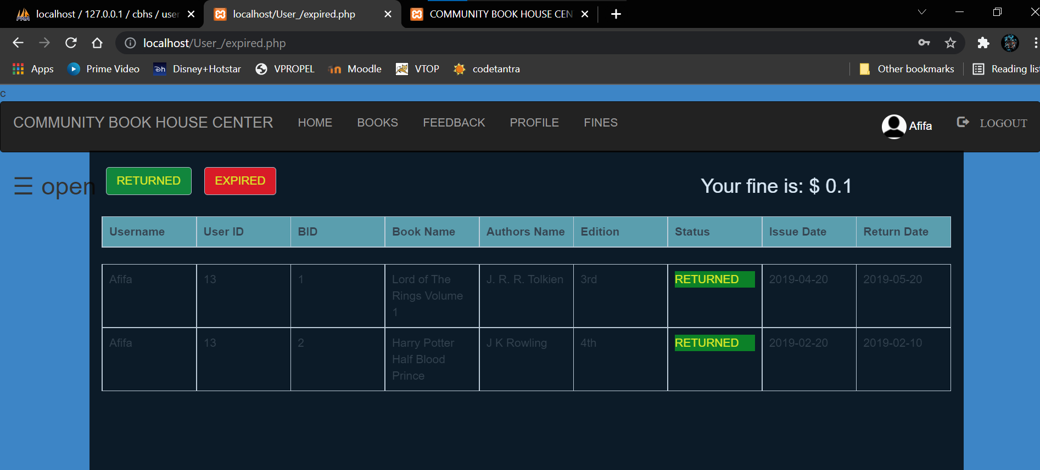**

**Fines**

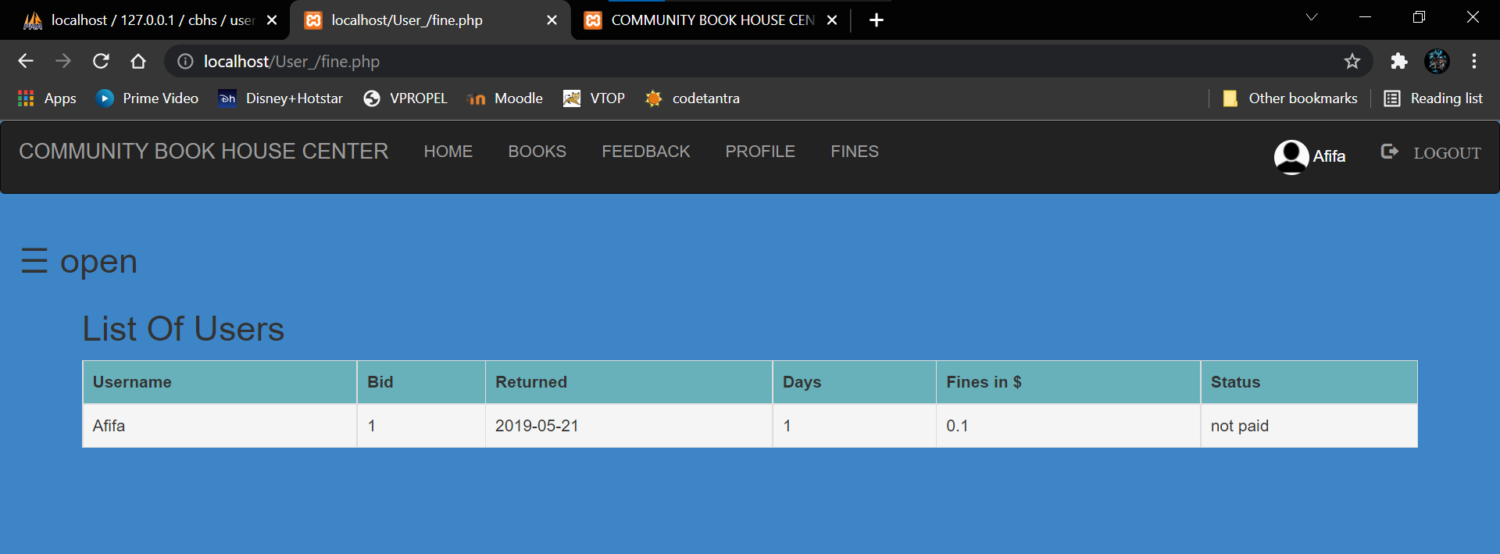

**Admin Home**

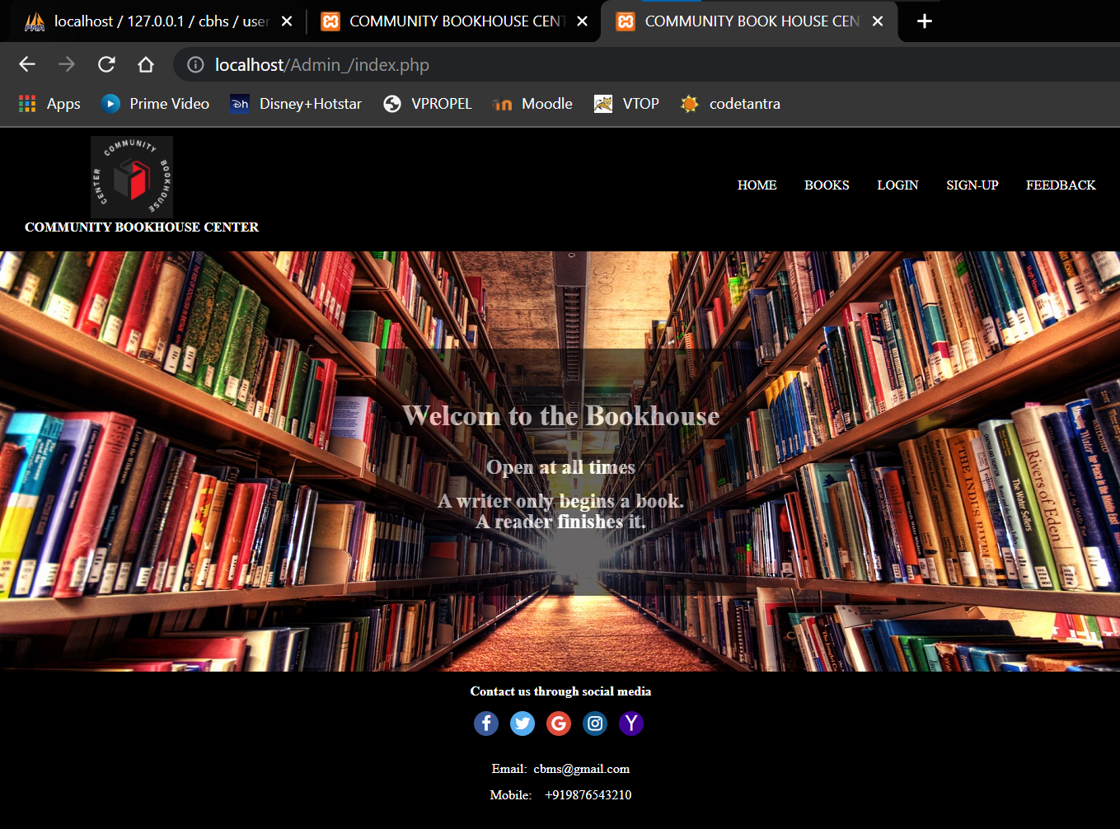

**Admin Login**

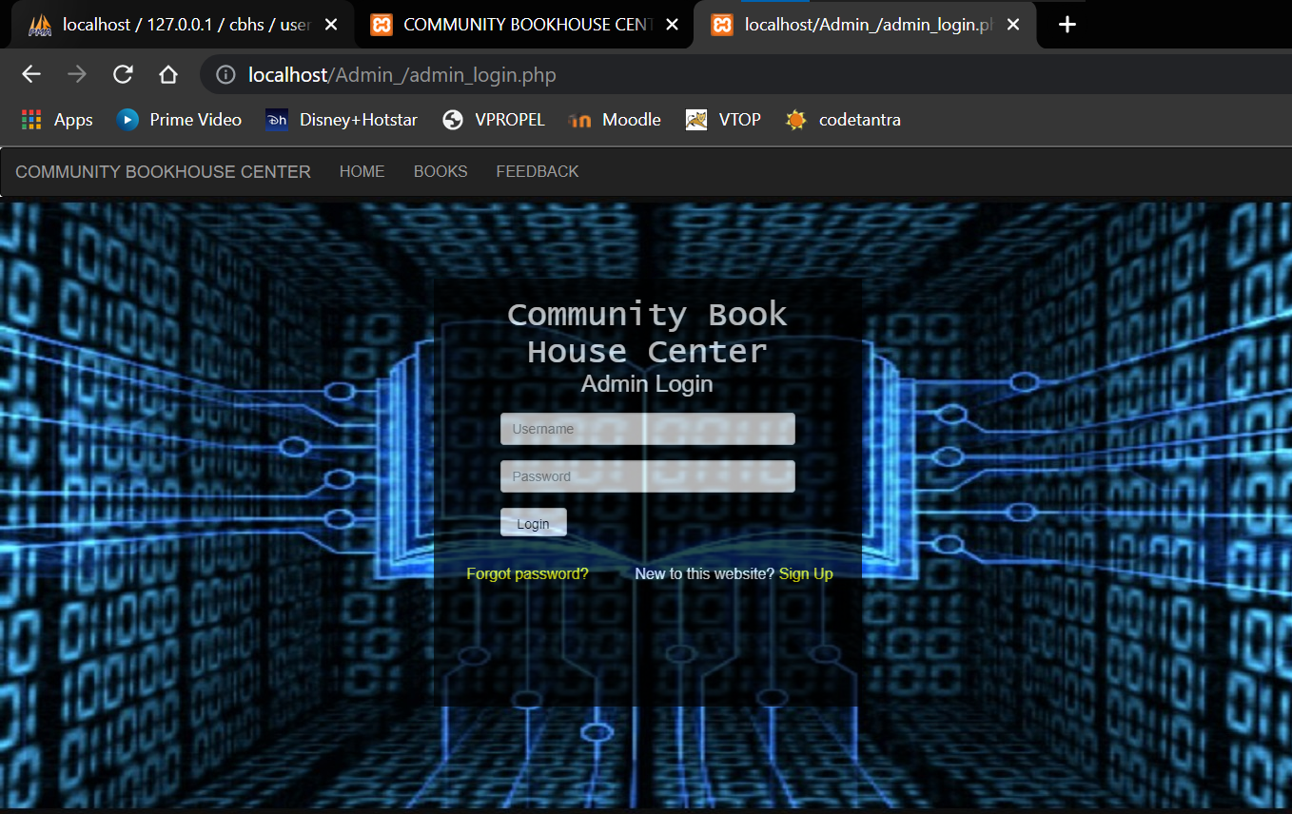

**Admin Profile**

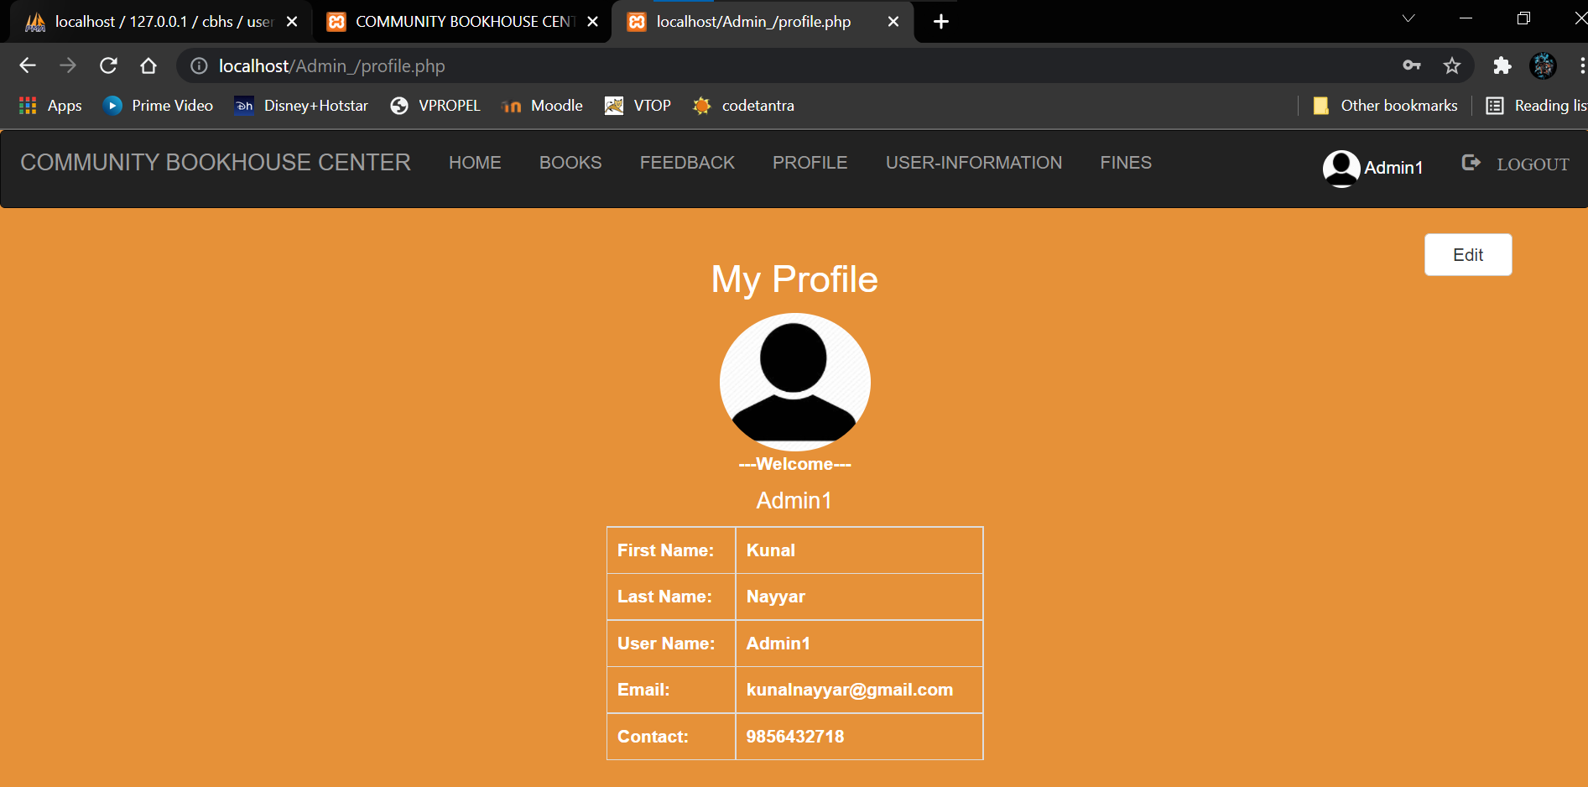

**Profile Edit**

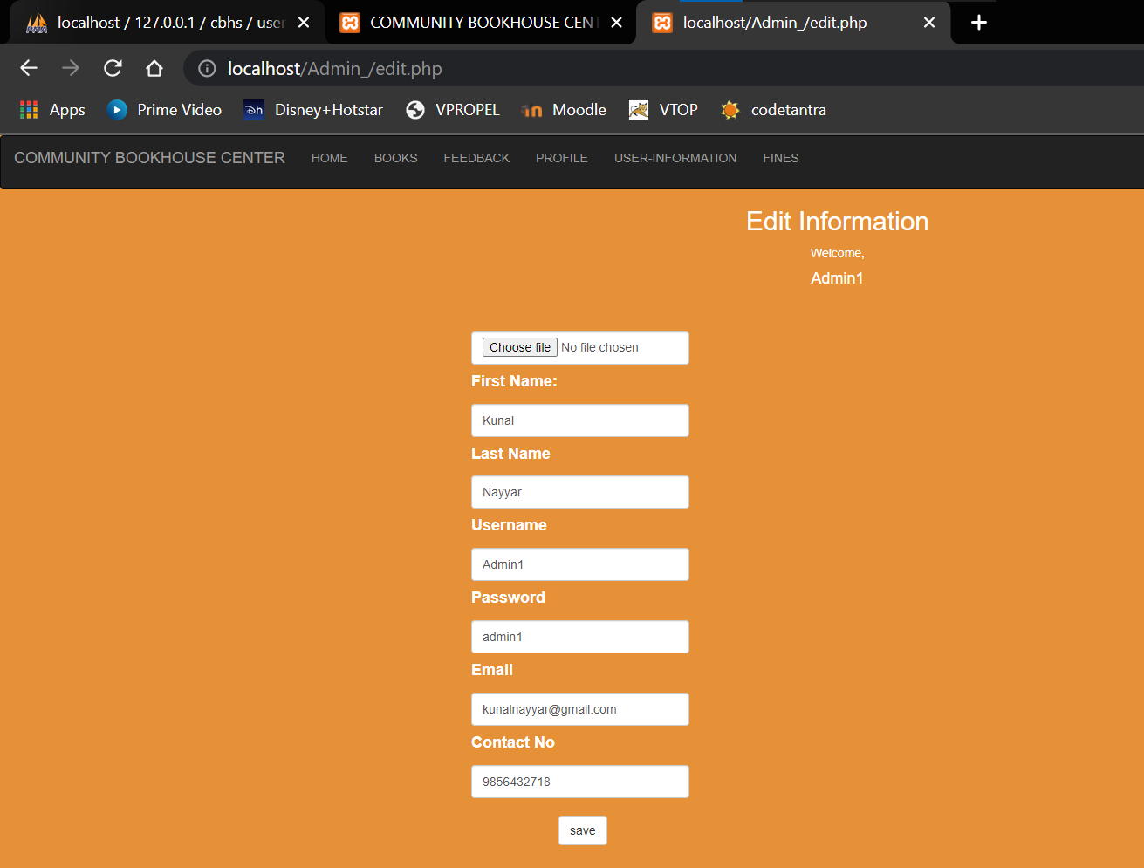

**User Information**

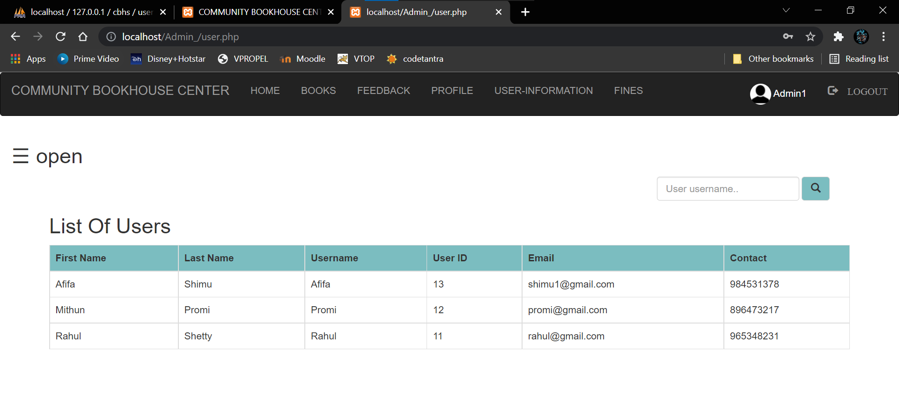

**Book Requests**

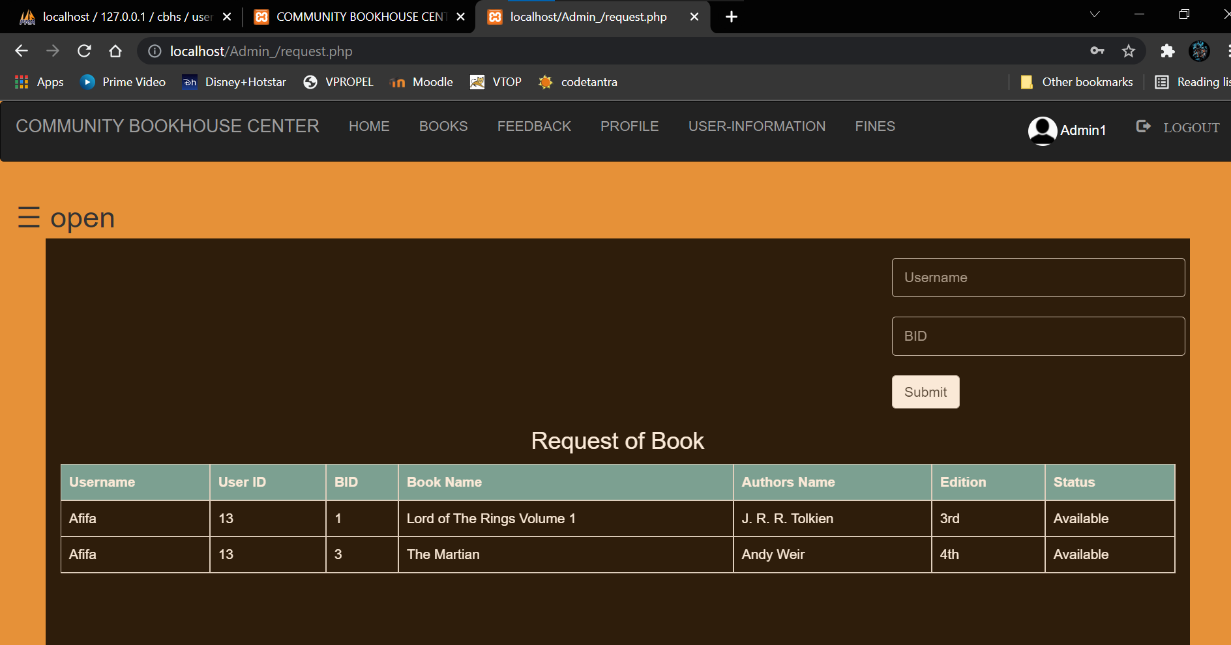

**Expired List (Admin Side)**

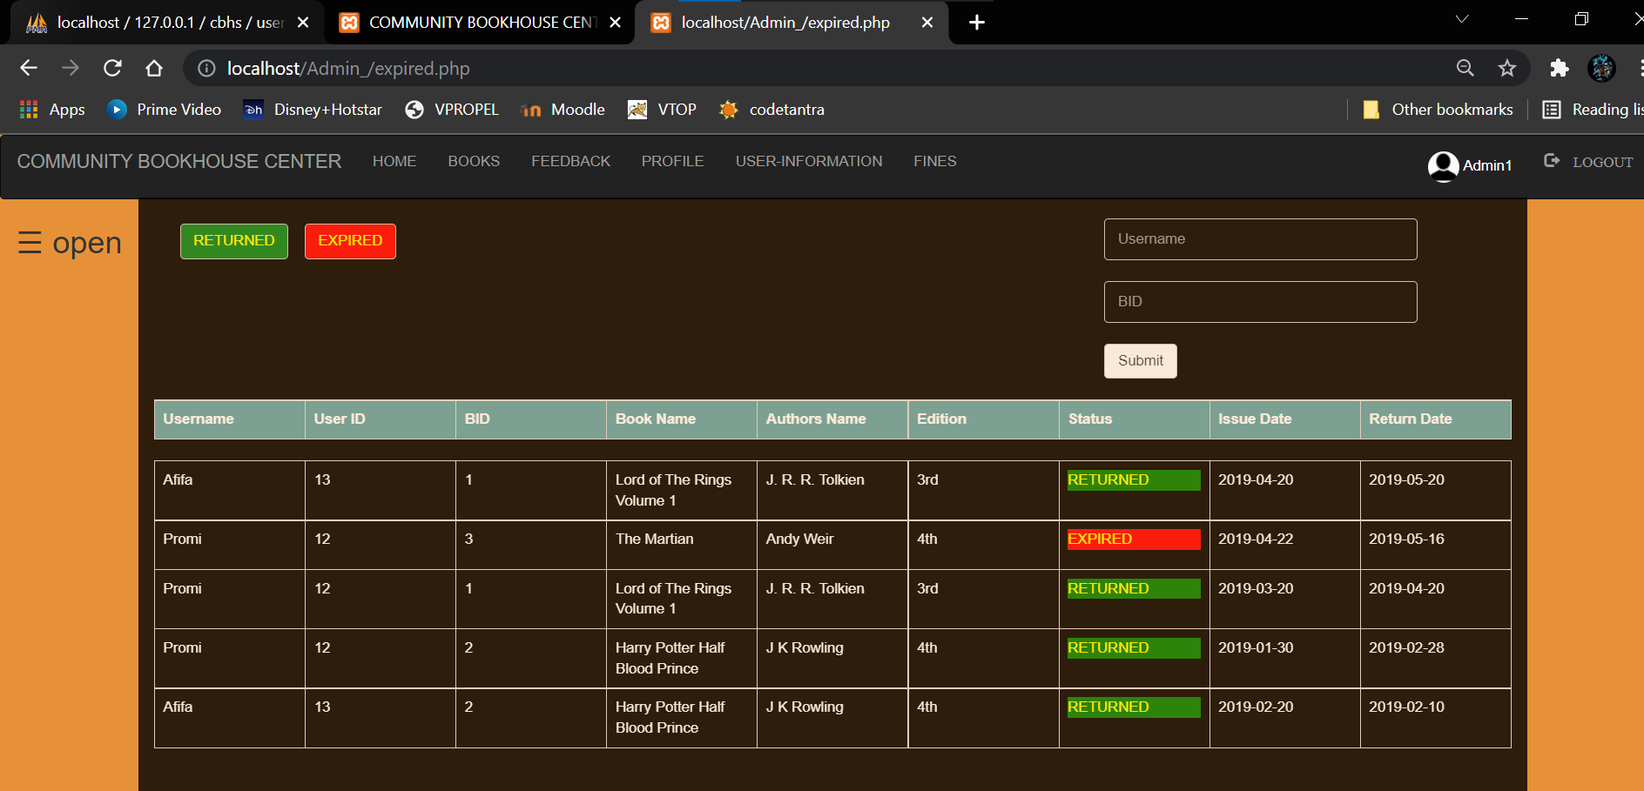

**Guest Donation**

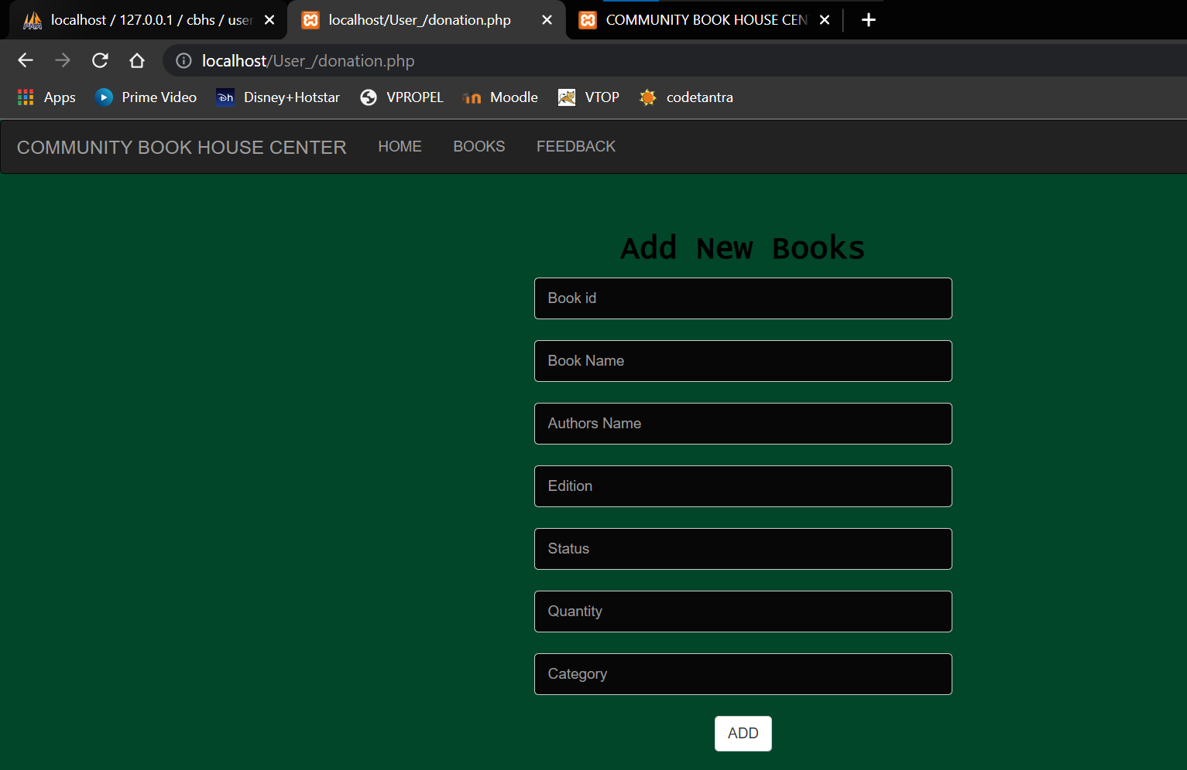

**Feedback**

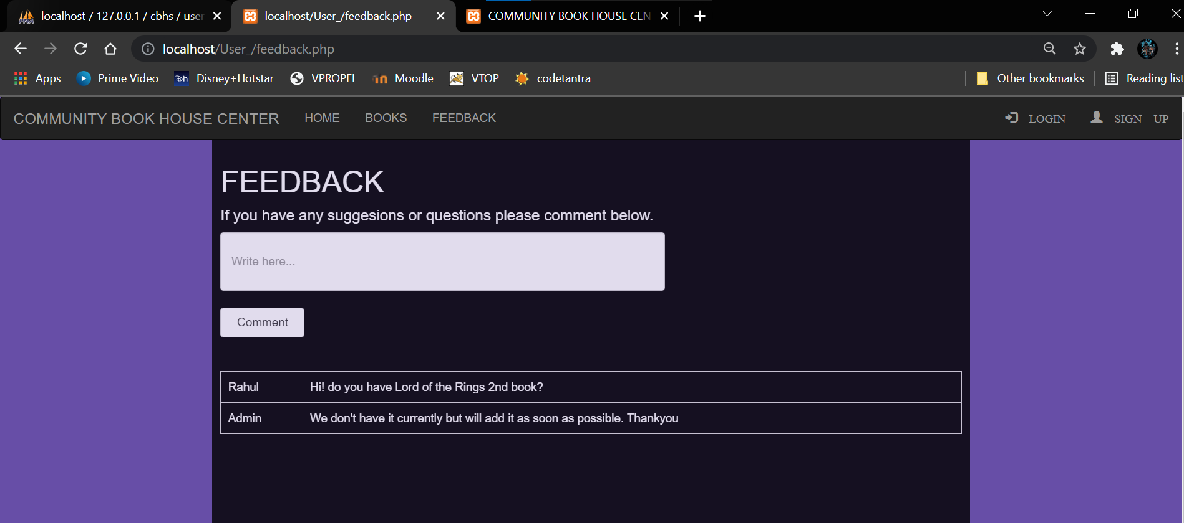

**CONCLUSION & FUTURE WORK**

* This website provides a computerized version of Community Book house Center which will benefits the staff of the Book House Center.
* It also provides an opportunity to the admin to maintain a user database and manage it accordingly, reducing the paper work.
* It makes entire process online where admin/user can search books. Through this project, admin can digitally monitor the status of books.
* It also helps in maintaining a systematic and structured database for newly issued, old as well as damaged books.
* There is a future scope that we can expand our network to other communities if this is successful And maybe in the future, books can be shared between nearby communities also. In this way, we won’t be facing the issue of lack of books since if a book if a book is not there in one Book House, one can access it from other one.

# REFERENCE

* <https://www.w3schools.com/>
* <https://www.tutorialspoint.com/index.htm>
* <https://www.javatpoint.com/>
* <https://www.freecodecamp.org/news/>